What is air conditioning packaging?

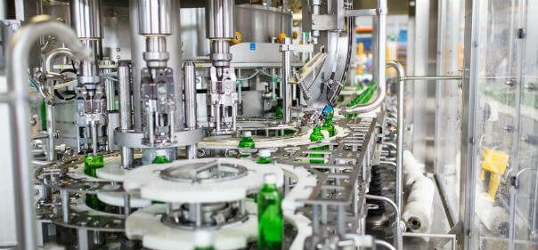
A major challenge facing the food manufacturing industry is the need to keep their products fresh for as long as possible. With the growth of globalized markets and increased consumer demand for food shelf life， the need for innovative food preservation methods is becoming increasingly important for food manufacturers who wish to remain competitive in a highly competitive market.
An increasingly popular solution to food storage problems is the use of modified atmosphere packaging. This alteration of the immediate atmosphere within the food package can significantly improve shelf life. This paper will discuss the concept of modified atmosphere packaging and its relevance to the food processing industry.
What is Modified Atmosphere Packaging (MAP)?
According to the FDA， modified atmosphere packaging is a controlled means of influencing the environment inside a package by reducing the level of oxygen. Its purpose is to maintain the freshness and quality of the contained food for as long as possible.
Comparison of modified atmosphere packaging and controlled atmosphere packaging
Although modified atmosphere packaging and controlled atmosphere packaging have many similarities， there are some subtle changes in what constitutes a modified atmosphere versus a controlled atmosphere.
First， modified atmosphere packaging is used in a more majority sense to describe a change in the environment in which the material is stored. Modified atmosphere packaging eliminates much of the natural air contained in the stored product， sometimes referred to as gas flushing.
Controlled atmosphere packaging， on the other hand， involves changing the composition of the air inside the product package. The nitrogen， oxygen and carbon dioxide levels within the package are altered to achieve optimal storage conditions. Maintaining the proper temperature and humidity within the storage facility is also critical.
Regardless of the procedure used， the integrity of the material and the environmental storage conditions must be fine-tuned to achieve optimal results.

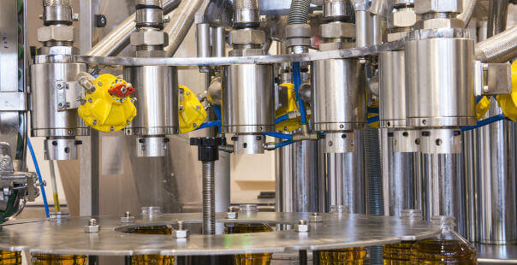
How does modified atmosphere packaging work?
As mentioned earlier， modified atmosphere packaging can be achieved through both active and passive methods. Active modified atmosphere packaging involves the introduction of the desired gas mixture into the packaging environment for the purpose of extending shelf life. In contrast， the passive approach of modified atmosphere packaging requires the use of special films to wrap the product to be preserved and therefore to regulate the temperature， humidity and the rate of diffusion of the gases inside the package.
Advantages of modified atmosphere packaging
The benefits of modified atmosphere packaging for storing and transporting food products include
Extended shelf life compared to other traditional storage methods
Improved visual appearance of packaged products
Preservation of nutrient content of food products
Extends the shelf life of food products
Elimination of chemical additives/preservatives
Preserves the original flavor of the food product
Types of modified atmosphere packaging
The most useful types of modified atmosphere packaging are outlined below.
Barrier films
The use of barrier films is a passive means of modified atmosphere packaging. Special films made from materials such as polyvinyl chloride (PVC)， polypropylene (PP) and low density polyethylene (LDPE) are now approved by the FDA for this purpose. In addition， new smart film technology provides indicators for packaging that can convey information about food quality， storage temperature， and alert users to leaks.
Desiccant Packs
Desiccant packs or oxygen scavengers are an effective way to change the environment inside modified atmosphere packages. Small desiccant packs (usually a mixture of ascorbic acid， activated carbon and iron powder) can be introduced into modified atmosphere packages to absorb excess moisture and oxygen from perishable foods.
One-way packaging valve
Another innovative modified atmosphere packaging technology involves the addition of one-way valves to products packaged in film. These valves will allow a one-way flow of gas from the package. This method allows the gas produced by the food to escape， preventing build-up that could reduce its shelf life.
Gas flushing
For food and beverage processing facilities engaged in large-scale operations， the use of gas flushing is often the most effective technique for changing the atmosphere of the packaging. Due to its non-reactive nature， the most used gas in flushing is nitrogen.
The use of nitrogen in food packaging helps to remove oxygen and other impurities from the production equipment， and can also be used as a filler gas for the food packaging itself. The inert nature of the gas will ensure that it does not alter the quality of the food material being packaged， while preventing oxidation processes and the growth of microorganisms that cause food spoilage.
Common modified atmosphere packaging gases
The most common gases used in modified atmosphere packaging are nitrogen， carbon dioxide and argon. These gases are selected based on their inert and anti-microbial properties.
Is nitrogen flushing bad for you?
Nitrogen used in gas flushing does not pose a health risk to consumers when applied in the right quantities under the right conditions. As always， this statement holds true only if the contained food is consumed before the specified expiration date.

