Variable pressure adsorption oxygen generation equipment

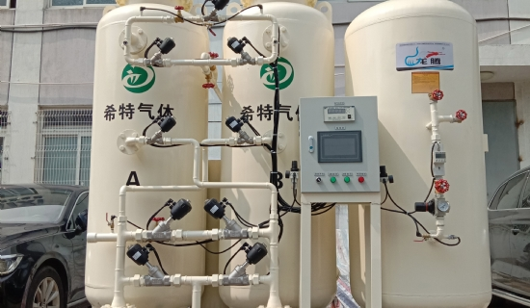
VPSA (Vacuum desorption) oxygen production equipment， that is， through the atmospheric pressure conditions， the use of VPSA special molecular sieve selective adsorption of nitrogen， carbon dioxide and water and other impurities in the air， under the conditions of vacuum desorption of molecular sieve， so as to cycle the production of high purity oxygen (90 ~ 94%).
Process Description
VPSA oxygen system mainly consists of blower， vacuum pump， switching valve， adsorber and oxygen balance tank. After the dust particles are removed by the inlet filter， the raw air is pressurized to 0.3-0.5barg by the roots blower and enters one of the adsorbers. The adsorber is filled with adsorbent， in which water， carbon dioxide and a small amount of other gas components are adsorbed at the entrance of the adsorber by the activated alumina filled at the bottom， and then the nitrogen is adsorbed by the zeolite molecular sieve filled at the top of the activated alumina. Oxygen (including argon) is the non-adsorbed component and is discharged to the oxygen balance tank as product gas from the top outlet of the adsorber.
When the adsorber reaches a certain level of adsorption， the adsorbent will be saturated， and then the vacuum pump is used to evacuate it through the switching valve (opposite to the direction of adsorption) with a vacuum of 0.65-0.75 barg. the adsorbed water， carbon dioxide， nitrogen and a small amount of other gas components are evacuated to the atmosphere， and the adsorbent is regenerated.
Each adsorber in the VPSA performs the following steps alternately:
--- adsorption --- desorption --- stamping
The above three basic process steps are automatically controlled by PLC and a switching valve system.
◇Process characteristics
1、 The energy consumption is relatively low. The larger the oxygen production， the lower the energy consumption.
2、 Low maintenance cost. The dynamic equipment is Roots blower and Roots vacuum pump， which are oil-free and easy to maintain because of their working principle.
3、 The automation of the whole set of equipment is high， the dynamic equipment and oxygen generator are synchronous control， just press the start button， the whole set of equipment can run normally.
4、 Suitable for medium and large production.

