What is a refrigerated compressed air dryer?

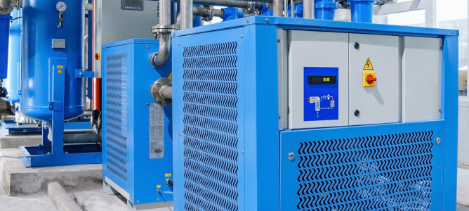
Compressed air is an important tool in a wide range of industries， serving as a power source for tools， equipment and processes. However， the air produced by compressors contains moisture in the form of water vapor.
If left untreated， this moisture can cause damage to pneumatic equipment， affect product quality and lead to costly downtime. To solve this problem， refrigerated compressed air dryers (the most common type of compressed air dryer) have become critical to many operations.
Refrigerated Compressed Air Dryers: The Basics
Refrigerated dryers are essential in many manufacturing and service applications， removing moisture from compressed air systems and preventing equipment damage due to corrosion and other issues.
Refrigerated air dryers work by reducing the temperature of the air to about 3°C or 35°F. When the air reaches this temperature (dew point)， the moisture in the air condenses and is then removed through a drainage system.
There are two types of refrigerated compressed air dryers: recirculating and non-recirculating.
Recirculating dryers turn the refrigeration compressor on and off depending on the demand for compressed air， and are therefore very energy efficient in application areas fields fields fields fields fields with varying air demand.
Non-recirculating dryers run the refrigeration compressor continuously regardless of air demand， providing a constant dew point， but use more energy than recirculating dryers.
Refrigerated Air Dryer Components
A refrigerated air dryer system consists of several basic components， including
Heat Exchanger - The heat exchanger is responsible for cooling the incoming hot， moisture-laden air. It utilizes a refrigeration cycle to cool the air， lowering its temperature and condensing the moisture.
Air-to-air heat exchanger - After the air is cooled， it passes through an air-to-air heat exchanger. Here， the air is reheated by the cool， dry air that is expelled. This process helps minimize temperature fluctuations and prevents condensation from forming on the outside of the dryer.
Moisture Separator - Condensed moisture needs to be separated from the compressed air. A moisture separator effectively collects and removes this liquid， ensuring that only dry air continues to enter the distribution system.
Refrigeration Compressor - The refrigeration compressor is the core component of the dryer and is responsible for circulating refrigerant through the system to maintain the desired temperature.
Applications for Refrigerated Compressed Air Dryers

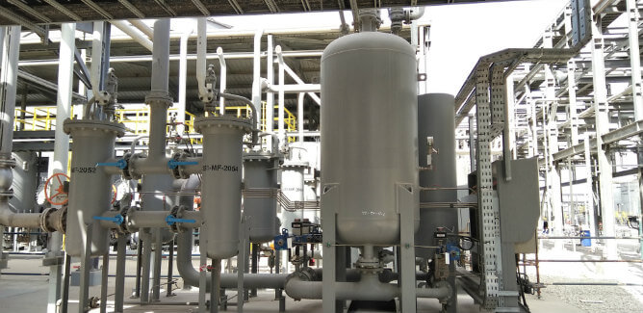
Refrigerant compressed air dryers can be used in a variety of industries， including
1. Manufacturing
During the manufacturing process， dry compressed air is essential to prevent moisture-related defects in products and to ensure consistent， high-quality production.
2. Automotive
In the automotive industry， compressed air is used to power pneumatic tools， painting and assembly line equipment. Dry air is essential to maintain the reliability of these processes.
3. food and beverage
Compressed air is commonly used in food and beverage production for tasks such as packaging， bottling and conveying. Ensuring that the air is clean and free of moisture is essential to prevent product contamination.
4. Pharmaceutical
Pharmaceutical production requires tightly controlled air quality. Refrigerated dryers are critical in maintaining the required standards of air quality and cleanliness.
Troubleshooting Refrigerated Compressed Air Dryers
Even the most reliable commercial air dryers can have problems from time to time. Here are some of the most common problems with refrigerated compressed air dryers and how to troubleshoot them.
No Cold Air
If a refrigerated compressed air dryer is not producing cold air， one of the most common reasons is a clogged air filter. Check the air filter regularly and replace it if necessary. Also， make sure the air intake is free of obstructions to promote proper airflow.
Additionally， insufficient refrigerant or a faulty compressor may cause warm air to be produced.
Excessive dew point
A high dew point may be due to a faulty thermostat or pressure gauge. Make sure the thermostat is set at the correct temperature for the application and is working properly. Check and recalibrate the pressure gauge if necessary.
It may also be the result of insufficient refrigerant levels or frozen evaporator coils. If this is the case， a professional technician may be needed to diagnose and fix the problem.
Excessive Condensate
Excessive condensate or standing water can be caused by a faulty drain valve， incorrect installation， or poor drainage design. Check the drain valve to make sure it is working properly.
Also， make sure the drain line is not clogged， kinked or too small， which would prevent proper drainage.
Increased energy bills
If you notice a sudden increase in your energy bill， your refrigerated compressed air dryer may be consuming more energy than it should. A clogged air filter， dirty evaporator coil， or malfunctioning thermostat could be the cause of the problem.
Make sure you clean the air filter and evaporator coil regularly to maintain efficiency. Also， check the thermostat settings to make sure they are not too low or too high

