We should learn the right aquaculture techniques
The essence of aquaculture is reflected in its key elements， including operating costs， sustainability and profitability. Location， climate， water availability and land are the key aspects that necessarily affect aquaculture.
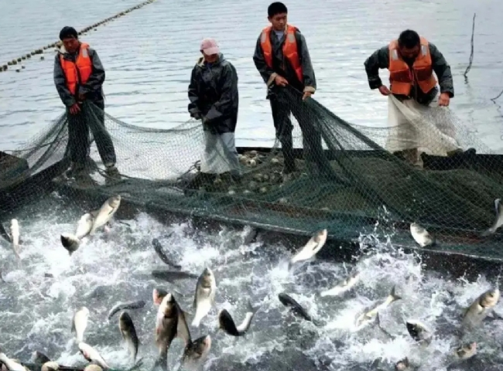
Actual aquaculture is driven by the market value of the product， the technology， the capital available for investment， the volume of production and the skills required. The methods used in aquaculture and the systems that support it have evolved rapidly over the years. We can see a clear difference between systems used in simple facilities (such as ponds)， oxygen generators， and high-tech systems.
Diversity of technologies
Aquaculture involves the use of relatively simple technological systems. They are adapted in small ways， all to improve the growth and survival of the target species. Systems used to raise herbivores and filter fish feed account for nearly half of global aquaculture production. This simple technology is designed to improve feed， oxygen levels， and provide protection from predators.
The factors that determine the best aquaculture technology are -.
1. the market and the ability to accept the cultured species.
2. development of goals and objectives with the target beneficiaries
3. the potential of the technology and its availability
4. the capital required for the investment
5. environmental conditions
6. accessibility of support facilities， production inputs and services.
The integration of new aquaculture technologies into traditional fish farming methods should better inform farmers of the latest technological advances.
Improving water quality
The quality of the water used in aquaculture has the potential to influence key factors that contribute to the growth process of fish. Dissolved oxygen， alkalinity and salinity， ammonia nitrate concentration and bacteria are the primary elements that may be affected by water quality. If good a result is desired， then aquaculturists must focus on monitoring these number parameters to ensure that fluctuations in these parameters are within specified reasonable limits.
In engaging in aquaculture， it is very important to utilize the latest technology. A technical background can help you to reduce costs and enhance efficiency through technology without affecting production levels.

