60 m3/h high purity variable pressure adsorption (PSA) nitrogen generator for controlled atmosphere cold storage

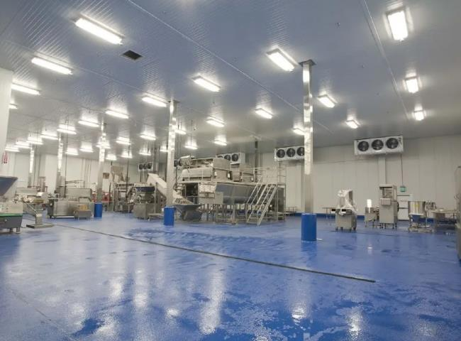
XITE supplied a nitrogen inert gas unit to a large ISO certified CA (Controlled Atmosphere) cold storage manufacturer. They needed nitrogen to change the normal air atmosphere.
The customer has purchased the following specifications of nitrogen equipment from XITE.
Technology: High Purity Pressure Shift Adsorption (PSA)
Capacity: 60 m3/h

Application: Controlled atmosphere cold storage for apples and other fruits
Controlled atmosphere cold storage process
Cold storage is a standard preservation chamber built on site according to the required dimensions and cooling specifications， with a range of machines providing a complete refrigeration solution. To counteract the natural ripening process， inert gases such as nitrogen are used to control the amount of oxygen in the air within the cold room， thereby slowing down the ripening process of the fruit. Commercially available gases for this duty are nitrogen and argon. Nitrogen is a natural choice because of its low cost and ease of production on site.
The combination of altered air atmosphere and reduced temperature in fresh fruit， most commonly apples and pears， allows for long periods of storage with only slow quality loss.
Cold storage manufacturers and turnkey suppliers often work with XITE to include on-site nitrogen generators in their supply range.
This specific project was a turnkey project completed by XITE and included screw air compressors， nitrogen production units and large size nitrogen storage tanks.
PSA nitrogen generator - for purity above 99.9%
PSA nitrogen generators are powerful systems for the production of nitrogen with a purity of 99.9% or higher.PSA is a very mature technology and XITE is a professional PSA nitrogen generator manufacturer in China， supplying more than 1200 nitrogen generators worldwide.

