Common uses of on-site nitrogen generators (PSA nitrogen generators， nitrogen equipment) in the oil and gas industry

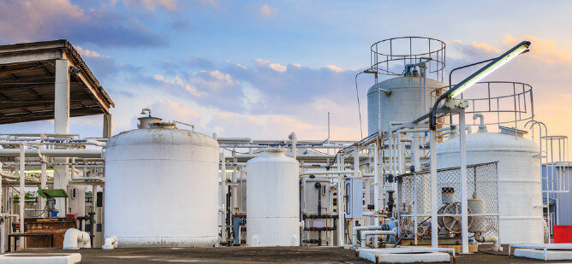

What is nitrogen?
Nitrogen is an element that occurs in abundance in nature， comprising 78% of air by volume and 75% by weight. It is an odorless， colorless， tasteless gas that is inert.
The industrial uses of nitrogen are diverse. However， our focus in this article will be on the oil and gas industry.
What are the uses of nitrogen?
Nitrogen is highly compressible， inert and miscible with water， making it suitable for a wide range of industrial applications. For example， pharmaceutical companies use high purity nitrogen to synthesize and preserve compounds used in the production of drugs.
Food processing companies use nitrogen in the packaging of perishable foods to increase shelf life. Metal manufacturers use nitrogen to prevent oxidation during the formation of new metals. Industries involved in the production of polymers use nitrogen to harden materials， such as plastics and rubber. These are just a few of the industrial uses of nitrogen.
Nitrogen is incredibly useful in the upstream oil and gas industry to stimulate production from brownfield or low permeability reservoirs. Due to its relatively inert nature， it does not cause downhole flaring as carbon dioxide and methane gases do.
Nitrogen applications in the oil and gas industry

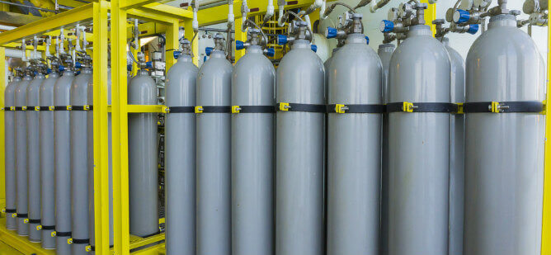

Industrial uses of nitrogen span both onshore and offshore applications， including.
- Nitrogen injection
- Pipeline drying
- Nitrogen purging
- Pressure testing
- Nitrogen capping
- Nitrogen Injection in Oil and Gas Wells
Typically， oil and gas wells experience a drop in formation pressure after a period of sustained production. During the primary recovery stage， this pressure is used along with pumping operations to flow hydrocarbons to the surface. During this stage， only 10-15% of the initial oil (OIIP) is recovered.
After a period of time， secondary recovery techniques such as gas lift (in the gas cap) and water injection (in the production zone) will be used to stimulate production by sweeping more oil and gas into the production pipeline to recover another 20-40%.
Enhanced oil recovery (EOR) methods can be used when secondary recovery methods are not sufficient to maintain production. When nitrogen is injected into reservoirs with insufficient pressure or low permeability， existing production can be maintained or enhanced. Carbon dioxide and methane can also be used， but nitrogen is more cost effective because it can be generated on demand and does not require extensive pipeline injection. EOR using nitrogen injection can help operators recover up to 60% of OIIP.
To perform nitrogen injection， pressurized nitrogen is injected into the reservoir， stimulating the flow of hydrocarbons from hard-to-reach areas. The operation uses nitrogen at a specific minimum mixing pressure. At very high pressures (up to 15，000 psi)， the nitrogen forms a miscible slug with a strong vaporization drive， resulting in improved oil and gas recovery.
Pipeline Drying
Pipeline drying is a nitrogen application used to displace contaminants， such as unwanted aerosols or to dry pipelines after hydrotesting， which is often required for pipeline commissioning.
Nitrogen Purge
Nitrogen purging is the process of displacing hazardous gases and mists from process systems to prevent unintended chemical reactions with volatile hydrocarbons and to reduce oxygen levels in explosive atmospheres.
Pressure Testing
Oilfield operators use nitrogen in pneumatic pressure testing of safety equipment， such as blowout preventers (BOPs)， Christmas trees (production) and pressure vessels.
Nitrogen Filling
Nitrogen blanketing or tank blanketing is the use of nitrogen in storage tanks to prevent volatile chemical reactions between chemicals or volatile hydrocarbons by displacing the oxygen present.
On-site nitrogen production and delivery of compressed gas cylinders

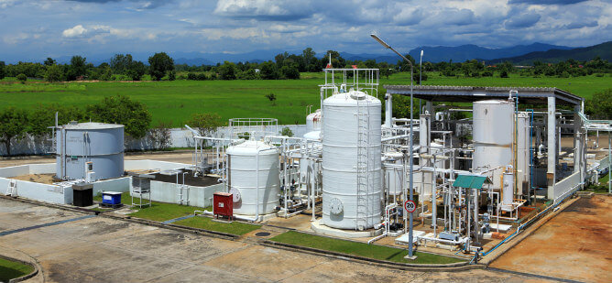

There are two main ways to achieve industrial utilization of nitrogen.
Nitrogen manufacturers generate nitrogen at their facilities， compress the gas into cylinders， and ship it to the customer's location for sale.
Industrial users generate nitrogen from the atmosphere on site.
- On-site nitrogen production is the most cost-effective option for companies that require a large supply of nitrogen.
- On-site nitrogen production offers several advantages over the use of cylinders， including
Safety and reliability. On-site nitrogen generators are modular， containerized systems that do not require frequent maintenance. Unlike cylinders， they are less prone to leaks and damage.
Unlimited supply. Unlike cylinders， which have a limited capacity， on-site nitrogen systems can produce a steady supply of product.
Cost savings. Nitrogen generators (PSA nitrogen generators， nitrogen equipment) save operators from the excessive logistics costs involved in transporting bulky cylinders to and from the site.
In order to generate a steady supply of nitrogen from the atmosphere， a nitrogen generator (PSA nitrogen generator， nitrogen equipment) is required. Suzhou XITE Gas provides manufacturing services for nitrogen generators (PSA nitrogen generators， nitrogen equipment) for oilfield operations.
What is a nitrogen generator?
A nitrogen generator (PSA nitrogen generator， nitrogen equipment) is a device that generates high purity industrial nitrogen from the atmosphere on demand. Nitrogen generators (PSA nitrogen generators， nitrogen equipment) can be either variable pressure absorption (PSA) or membrane types.
PSA nitrogen generators separate the individual components of air based on their molecular properties and affinity for an adsorbent medium such as zeolite or granular activated carbon， while membrane generators work by using semi-permeable membranes to separate pure nitrogen from the atmosphere.

