Cryogenic process of air separation

Low temperature process of air separation
Air consists of a variety of gases， of which nitrogen (N2) and oxygen (O2) account for 99.03% of the total sample volume. There are about 78.08% nitrogen， about 20.95% oxygen and about 0.93% argon in the dry air， as well as traces of other gases， such as hydrogen， neon， helium， krypton， xenon and carbon dioxide. Ambient air may contain varying amounts of water vapor (depending on humidity) and other gases produced by natural processes and human activities. Oxygen and nitrogen are produced through the air separation process， which requires the separation of air into its components. Rare gases， such as argon and krypton， can be recovered as by-products of the air separation process.
The separation of air into its constituent gases is accomplished by implementing specific air separation techniques. At present， there are different air separation technologies， each of which aims to take advantage of the different properties of the physical properties between the air components. In other words， the air separation technology is based on the fact that each component gas in the air has different physical properties. Therefore， the air separation is realized by using certain physical properties， such as (I) distinguishing the molecular size of the component gas， (II) distinguishing the diffusion speed difference through some materials， (III) adsorption preference of special materials for certain gases， and (IV) difference in boiling point temperature， etc.
Some of the technologies used today include low temperature， adsorption， chemical processes， polymeric membranes， and ion transport membranes (ITMS). Among these technologies， low-temperature air separation technology is in the mature stage of its life cycle. Therefore， it is the only feasible means among the currently available technologies for large-scale production of oxygen， nitrogen， argon and other air products.
Air separation technology is used to produce oxygen and / or nitrogen， sometimes as a liquid product. Some plants also produce argon， either gas， liquid， or both. All air separation processes begin with compressed air. All air separation plants use non cryogenic technology or cryogenic technology. Air separation plants using non cryogenic air separation technology use a separation process close to ambient temperature to produce gaseous oxygen or nitrogen products. These plants typically produce oxygen of 90 to 95.5 percent purity， or nitrogen of 95.5 to 99.5 percent oxygen free. Air separation equipment can produce more than three times more nitrogen than oxygen， but usually maintain a ratio of 1:1 to 1.5:1.
The low temperature process was first developed by Karl von Linde in 1895 and improved by George Claude in the 1900s. It is used for small-scale production of oxygen to meet the requirements of various industrial processes， such as welding and cutting， and as a medical gas.
Industrial scale cryogenic air separation began in the early 20th century， which promoted the development of metallurgical industry and other industrial sectors that are highly dependent on oxygen， nitrogen and ultimately argon. Low temperature air separation equipment (ASP) is characterized by good product quality， large capacity and high reliability. Despite other emerging air separation technologies， cryogenic air separation technology is still the basic technology for oxygen production. Cryogenic air separation equipment is most commonly used to produce high purity gas products. However， for applications that require a large amount of gas， the use of this technology is limited， usually requiring hundreds of tons of separated gas per day. They can produce gaseous or liquid products.
Low temperature air separation technology uses the difference of boiling point of gas for separation. It is based on the fact that different components of air have different boiling points， and air can be separated into its components by manipulating the direct environment in terms of temperature and pressure. The boiling point of oxygen at 1 atmosphere and 0 ℃ is minus 182.9 ℃， and the boiling point at 6 atmospheres and 0 ℃ is minus 160.7 ℃. The corresponding boiling points of nitrogen are minus 195.8 ℃ and minus 176.6 ℃， and the boiling points of argon are minus 185.8 ℃ and minus 164.6 ℃ respectively.
Low temperature separation is the most effective process when any of the three criteria needs to be met， i.e. (I) high purity oxygen (higher than 99.5%)， (II) large amount of oxygen (greater than 100 tons of oxygen / day)， or (III) high pressure oxygen. The low temperature air separator needs more than one hour to start. In addition， since the cryogenic technology can produce such high purity oxygen， the waste nitrogen stream also has available quality. This can increase considerable economic benefits for the process combined with low temperature air separation equipment.
The separation of air into its constituent gases at low temperature involves various processes. These processes need to be combined in cryogenic air separation equipment， the most basic of which are (I) air compression， (II) air purification， (III) heat exchange， (IV) distillation， and (V) product compression. Figure 1 shows these processes.

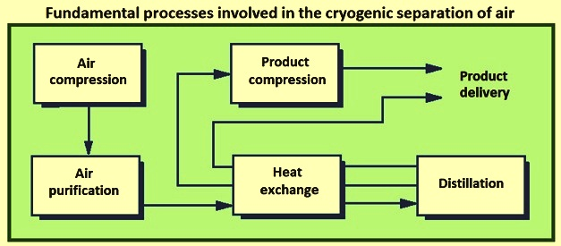
Figure 1 involves the basic process of cryogenic air separation
The cryogenic air separation equipment is based on the cryogenic air separation process. Since its commercialization in the early 20th century， the basic process as an industrial process has been developing continuously. A large number of process configuration changes have occurred due to the desire to produce specific gas products and product combinations as efficiently as possible at various required purity and pressure levels. These air separation process cycles are developing synchronously with the progress of compression machinery， heat exchanger， distillation technology and gas expander technology.
The distillation process is the core of the whole process because it actually separates air into its components. The air products produced have a certain purity， which is defined as the ratio of the quantity of 100% pure air products to the total amount of air products output.
In the distillation process， trays were used. The basic function of the tray is to effectively contact the falling liquid with the rising gas. Thus， the tray provides a stage for (I) cooling and partially condensing the rising gas， and (II) heating and partially vaporizing the falling liquid. Figure 2 shows a typical distillation column with a fractionation tray. This distillation column has only one vaporizer and one condenser. Distillation is achieved by effective liquid gas contact， which is achieved by proper contact between the falling liquid and the rising gas. The purity of the most volatile and less volatile elements is different on each tray. The lower and upper sides of the distillation column are two extremes， which is also the place to obtain pure elements.

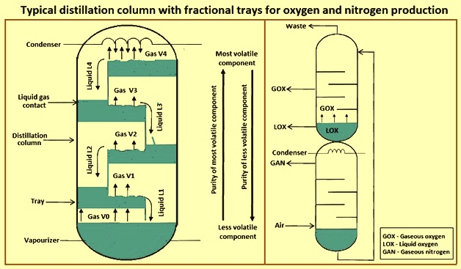
Figure 2 typical distillation column with fractionation tray for oxygen and nitrogen production
Figure 2 shows that the tray provides some resistance to the rising gas， resulting in a pressure drop. The pressure drop should be as small as possible because it has a great impact on the energy consumption of the air compressor and is also an important parameter for the development of pallet technology. Distillation packing is another technology in use that ensures a much smaller total pressure drop and improves liquid gas contact compared to partial distillation trays.
In order to produce oxygen， a liquid mixture of oxygen and nitrogen and a column with a vaporizer at the bottom are required. In order to produce nitrogen， a gas mixture of oxygen and nitrogen and a column with a condenser at the top are required. In this process， a byproduct rich in oxygen gas will also be produced. By stacking the two types of columns together and transferring the oxygen enriched liquid obtained at the bottom of the nitrogen column to the top of the oxygen column， it is possible to produce oxygen and nitrogen with only one condenser. This is shown in Figure 2.
The oxygen rich liquid enters the top of the upper distillation tower and generates liquid oxygen (LOX) at the bottom of the same tower through distillation. Through the heat exchange between the gaseous nitrogen (GAN) at the top of the lower distillation column and the liquid oxygen at the bottom of the upper distillation column， the liquid oxygen is vaporized into gaseous oxygen (GOx). A waste product will also be produced at the top of the upper tower， which is composed of a mixture of nitrogen and oxygen.
In practice， the function of condenser is completed by a heat exchanger， which ensures proper heat transfer from Gan to LOX， and vice versa， so as to vaporize LOX and condense Gan， which is required for continuous operation of distillation column. In this model， the distillation columns are stacked on top of each other， but it is also possible to place them side by side， as is occasionally done in practice.
Cryogenic air separation process is an energy intensive cryogenic process， which separates air into its constituent gases. The energy consumption of oxygen separation is an increasing function of oxygen purity. The power cost is the largest single operating cost incurred by the air separation plant. It is usually within one-third or two-thirds of the operating costs associated with the production of gaseous and liquid products. As oxygen， nitrogen and argon are widely used in the steel industry， the price of these gases affects the production cost of steel and steel products. The energy efficiency of ASP is largely affected by the production ratio of oxygen and nitrogen， which can vary according to demand.
The minimum thermodynamic work for separating oxygen from air is equal to 53.1 kwh / ton of oxygen. At present， the best low-temperature ASP is characterized by energy consumption exceeding about three times the minimum value of thermodynamics.
The complexity of the cryogenic air separation process， the physical size of the equipment and the energy required for the operation process vary with the quantity of gaseous and liquid products， the required product purity and the required delivery pressure. Plants that produce only nitrogen are less complex and require less energy to operate than plants that produce only oxygen. CO production of the two gases increases capital costs and energy efficiency. The production of these gases in liquid form requires additional equipment， and the power required per unit of gas delivered is more than doubled.
Argon production is economical only as a by-product of oxygen. Producing it with high purity increases the physical size and complexity of the air separation plant. The flow chart of a typical low temperature air separation plant is shown in Figure 3. The flow chart shows the typical interrelationship between the various components of the plant. However， the actual relationship depends on the design of the air separation plant， which can vary to meet the requirements.

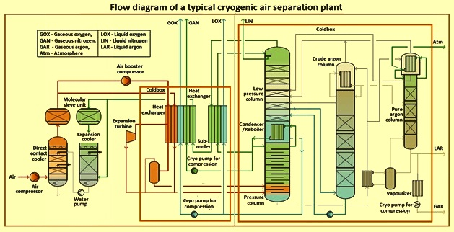
Fig. 3 flow chart of a typical low temperature air separation plant
Steps in the cryogenic process of air separation
There are several steps in the cryogenic process of air separation. The first step is to filter， compress and cool the incoming air. In most cases， the air is compressed between 5 MPa and 8 MPa， depending on the product structure and the required product pressure. In this step， the compressed air is cooled. When the air passes through a series of interstage coolers and the aftercooler after the last stage of compression， most of the water vapor entering the air is condensed and removed.
The second step includes the removal of impurities， in particular， but not limited to， residual water vapor and carbon dioxide (CO2). These components are removed to meet product quality specifications and before the air enters the distillation section of the plant. There are two basic ways to remove water vapor and carbon dioxide. They are (I) molecular sieve units (II) reverse exchangers. Most new air separation plants use molecular sieve pre purification devices to remove water vapor and carbon dioxide from the incoming air. Heat exchangers used to remove steam and carbon dioxide are more cost-effective for smaller plants. In plants using reversing heat exchangers， cooling of the compressed air feed is accomplished in two sets of brazed aluminum heat exchangers. When a reversing heat exchanger is used， install a cold absorption device to remove any hydrocarbons.
The third step is for the extra heat transfer of product and exhaust gas flow to make the air flow reach a low temperature (- 185 ℃). This cooling is carried out in a brazed aluminum heat exchanger， which allows heat exchange between the incoming air feed and the cold product and exhaust stream leaving the separation process. During the heat exchange process， the leaving gas stream is heated to a temperature close to the ambient air temperature. Recycling refrigeration from gaseous product streams and exhaust streams can minimize the amount of refrigeration produced by the plant. The very low temperature required for cryogenic distillation is generated by a refrigeration process， including the expansion of one or more high-pressure process streams.
The fourth step is the distillation process， which separates the air into the desired product. In order to produce oxygen， the distillation system uses two distillation columns in series， commonly referred to as high-pressure and low-pressure columns. Nitrogen plants can have only one column， although many have two. Nitrogen leaves the top of each column， while oxygen leaves the bottom. The impure oxygen generated in the initial (high pressure) tower is further purified in the second low pressure tower. The boiling point of argon is similar to that of oxygen， and it is preferred to stay with oxygen. If high purity oxygen is required， argon must be removed. Argon removal is carried out at the place with the highest argon concentration in the low-pressure column. The removed argon is usually treated in an additional "traction" crude argon distillation column， which is combined with a low-pressure column argon refining facility. Cold gaseous products and crude argon can be discharged for further treatment on site， or collected as liquid， or vaporized to produce gaseous argon.
The waste stream from the air separation column is sent back through the heat exchanger at the front end. When they are heated to near ambient temperature， they cool the incoming air. The heat exchange between the feed and product streams minimizes the net cooling load of the plant， thereby minimizing energy consumption.
Refrigeration is generated at a low temperature level to compensate for heat leakage into the cooling equipment and imperfect heat exchange between incoming and outgoing gas flows. In the refrigeration cycle of the air separation plant， one or more high-pressure gas streams (which can be intake， nitrogen， exhaust， feed gas or product gas， depending on the type of plant) are reduced in pressure to cool the gas stream. In order to maximize cooling and plant energy efficiency， decompression (or expansion) is carried out in an expander (a form of turbine). Remove energy from the gas stream， making it cooler than simple expansion through the valve. The energy generated by the expander is used to drive the process compressor， generator or any other energy consuming equipment.
Gaseous products usually leave the cold box at a relatively low pressure (an insulated container containing distillation columns and other equipment operating at very low temperatures)， often just above one atmospheric pressure (absolute value). In general， the lower the delivery pressure， the higher the efficiency of the separation and purification process. The product gas is then compressed in the compressor to the pressure required by the product gas for its use.
The parts (such as distillation column， heat exchanger and cold interconnection pipeline) operating at very low temperature in the low-temperature air separation process shall have good insulation. These items are located in the "cold box" of the seal (and nitrogen purging)， which is a relatively high structure with a rectangular or circular section. Rock wool is installed in the cold box to provide insulation and minimize convection. According to the type and capacity of the plant， the side length of the cold box can reach 2 to 4 meters， and the height can be 15 to 60 meters.
Argon production
Pure argon is usually produced from crude argon through a multi-step process. The traditional method is to remove 2% to 3% oxygen in the crude argon in the "deoxygenation" device. These small devices chemically combine oxygen and hydrogen in a container containing a catalyst. The resulting water is easily removed (after cooling) in the molecular sieve dryer. The oxygen free argon stream is then treated in a "pure argon" distillation column to remove residual nitrogen and unreacted hydrogen.
The progress of packed column distillation technology has created the second argon production mode， i.e. complete low-temperature argon recovery. It uses a very high (but small diameter) distillation column for difficult argon / oxygen separation. The amount of argon a plant can produce is limited by the amount of oxygen processed in the distillation system， plus other variables that affect the recovery rate. These variables include the amount of oxygen produced as a liquid and the stability of plant operating conditions. Due to the proportion of naturally formed gas in the air， the argon production shall not exceed 4.4% of the oxygen feed rate by volume or 5.5% by weight.
Production of liquid products
When liquid products are produced in a cryogenic air separation plant， a supplementary refrigeration unit is usually added (or integrated) into the basic air separation plant. This device is called liquefier and uses nitrogen as the main working liquid. The capacity of the liquefier can range from a small part of the capacity of the air separation unit to the maximum production capacity of oxygen plus nitrogen and argon of the air separation unit.
The basic process cycle used in the liquefier has not changed for decades. A typical liquefier takes in nitrogen near ambient temperature and pressure， compresses it， cools it， and then expands the high-pressure gas flow to produce refrigeration. The basic difference between the newer and older liquefiers is that with the improvement of the manufacturing technology of the low-temperature heat exchanger， the maximum working pressure level of the low-temperature heat exchanger has been increased. If a typical new liquefier adopts a higher peak circulating pressure and a more efficient expander， its energy efficiency may be higher than that of the liquefier 30 years ago.

