Should a hydrogen generator be installed on site?

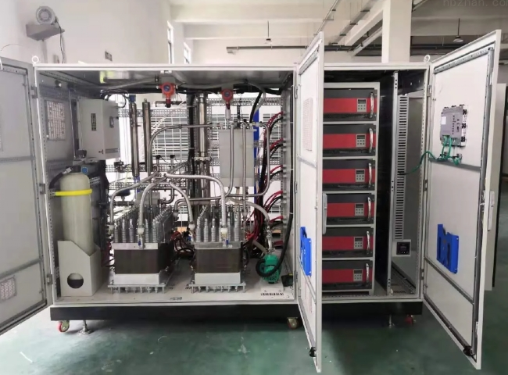
Hydrogen is the most abundant component in the universe; however， it is not naturally available in gaseous form on Earth. Hydrogen must be manufactured in the gaseous form. The carbon and hydrogen atoms in hydrocarbon fuels are separated by steam reforming for wider use in industrial production. Hydrogen is used in various laboratory applications， such as ICP-MS and gas chromatography. It is used in food industry production to hydrogenate oils to fats and in chemical industry production to synthesize cyclohexane， methanol and ammonia.
Numerous studies and developments have declared that on-site hydrogen generators are safer， more environmentally friendly， more cost effective and more efficient to generate on-demand hydrogen for all industrial uses. Hydrogen has been proven to be a safe fuel as it is now being used as a clean "non-polluting" fuel for automobiles.
Which is the best method for producing hydrogen?
The best method for producing high purity hydrogen on site is electrolysis of water. The electrolysis reaction takes place in an electrolytic cell， which is the most important generator element. The cell consists of two electrodes， the cathode and the anode， which are separated by an ion exchange membrane. A platinum catalyst is used on the electrodes to produce high purity hydrogen with a purity of up to 99.9995%.
Why choose a hydrogen generator?
XITE on-site hydrogen generators are the safest， most convenient and economical solution. These generators will provide an uninterrupted supply of hydrogen of the purity required by the user. It also puts an end to all the risks， such as variations in gas quality and handling of high pressure cylinders.
The use of on-site gas generators allows the user to produce hydrogen when needed. Thus， the user can safely avoid the risk of running out of gas. It also reduces the costs associated with labor and there is no need to order， replace or manage gas cylinders.
XITE's on-site hydrogen generators are an environmentally friendly alternative to gas cylinders. Our generators involve zero or no maintenance.

