What is a desiccant air dryer and how does it work?

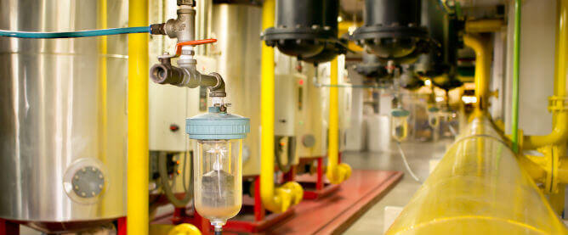
It is virtually impossible to obtain moisture-free air directly from the environment for industrial use. Failure to remove excess moisture from industrial compressed air can compromise the quality of the process air and damage moisture-sensitive machinery.
What is a desiccant?
A desiccant is a substance or material that absorbs moisture from its surroundings. It is commonly used to reduce the humidity or moisture content of air， gases or solids， thereby preventing corrosion， mold and other undesirable effects associated with high humidity.
Types of Desiccants
Most desiccant materials are chemically stable， but some are toxic and should only be used under special conditions. The most common types of desiccants include
Silicon Dioxide - A common desiccant made from silicon dioxide， known for its high adsorption capacity and versatility.
Activated Carbon - Activated carbon is known for its porous structure and is used to adsorb moisture and impurities.
Calcium Chloride - Calcium chloride is an effective desiccant and is usually used in the form of hygroscopic pellets or bags.
Calcium Sulfate - This desiccant is used to control moisture and is commonly used in a variety of industries.
Aluminosilicate Minerals (Zeolites) - Zeolites are microporous minerals with a high surface area that adsorb water and other molecules.
Desiccants are used for both everyday household use and large-scale industrial applications such as compressed air drying.
What is a desiccant air dryer?
A desiccant dryer or adsorption dryer is an industrial device that uses desiccant materials to remove moisture from air. Standard desiccant dryer systems utilize a dual tower setup to ensure an uninterrupted air drying cycle.
What is a Regenerative Dryer?
The term "regenerative" refers to industrial dryers that can renew desiccant material by reversing the adsorption process. Typically， regenerative dryers have paired desiccant-filled towers that allow for simultaneous adsorption and material regeneration.
Twin Tower Desiccant Compressed Air Dryers
Twin tower dryers are essentially dual desiccant systems that are constantly switching between absorption and regeneration modes. Indicators detect water saturation in each tower and automatically switch phases when appropriate.
How does the dryer work?
This dryer has two towers that are equally filled with hygroscopic material. During daily operation， one tower is used to actively remove moisture from the compressed air passing through it， while the other tower performs the reverse operation， actively removing moisture to "regenerate" the desiccant material.
Once the desiccant in the absorption tower is saturated and the material in the second tower is sufficiently dry， the control equipment automatically reverses their functions. Through this phase change， the desiccant in the absorption tower and the second tower's

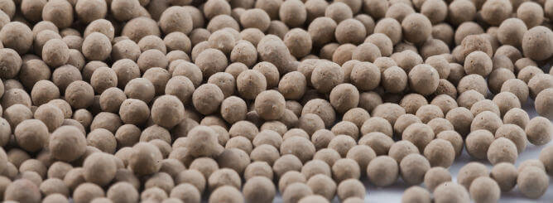

How to regenerate desiccant microbeads
Regeneration of desiccant materials is achieved by avoiding their accumulation of moisture during the compressed air drying cycle. There are different regeneration methods for hygroscopic materials used in air drying systems.
Hot air desiccant regeneration
This method involves forcing a stream of heated air through a tower of water-saturated desiccant to avoid moisture in it. This drying technique requires a fan and an electric heater to dry the desiccant.
Regeneration of desiccant using dry compressed air
Regenerating the desiccant with partially freshly dried compressed air is very energy efficient and can save the operator additional utility costs.
Drying the desiccant with a special drying system
This air dryer system regenerates the desiccant and dries the compressed air at the same time. The air dryer utilizes a rotating drum system in which one quarter of the drum is used for desiccant regeneration and the rest dries the compressed air at the same time.
Common Applications for Desiccant Air Dryers
Desiccant air dryers are widely used in industries that utilize compressed air. For example， the oil and gas industry relies on compressed air for a variety of operations such as oil extraction， refining and transportation.
In most industries， the use of desiccant air drying systems prevents rapid wear and damage to moisture-sensitive components.

