Working principle of PSA nitrogen generator

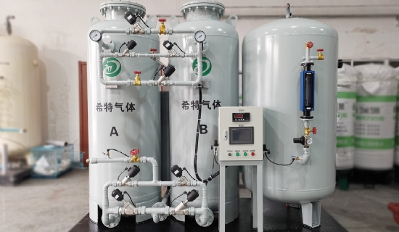
Pressure Swing Adsorption (PSA) is one of the widely used technologies for on-site nitrogen production for industrial and medical applications.PSA nitrogen generators consist of two adsorbers filled with carbon molecular sieves that have the ability to adsorb oxygen from compressed air. The PSA process works by drawing in ambient air， which is then filtered and compressed. The oxygen is adsorbed in the carbon molecular sieve while the nitrogen-rich gas moves through the adsorber. The process has the ability to reduce the oxygen concentration to the required specification.
Technical specifications:-
Capacity range: 25 m3/h to 1000 m3/h
Nitrogen purity: 99.99
Nitrogen pressure: up to 25 bar
Dew point: -40 degrees Celsius to -80 degrees Celsius
How does a PSA nitrogen generator work?
While adsorption is completed in one adsorber， the second adsorber is completely regenerated by depressurizing to ambient pressure. The oxygen is moved back into the atmosphere. After a period of adsorption in one adsorber， the second adsorber is activated by the process controller to produce nitrogen without interruption. Our PSA nitrogen plants are manufactured from the most medium to large size materials and are known for their long lasting performance and ease of operation.
Membrane Nitrogen Plants
In addition to PSA， membrane technology is becoming one of the industry's larger processes for generating high purity nitrogen. It is preferred because of its lower initial investment and energy consumption compared to PSA technology. The membrane air separation process works by bringing ambient air into the membrane module， where the gas is separated based on the difference between diffusivity and solubility. In this process， the separation of oxygen from the ambient air occurs upstream because of its high diffusivity， while nitrogen is collected downstream.
Advantages
The cheapest method of nitrogen production
High purity with low amount of nitrogen and vice versa
Seamless airflow design for high reliability
Operates at lower pressures
Industrial Applications
Nitrogen is used in a wide variety of industries， some of which are listed below.
Pharmaceuticals
Nitrogen is widely used in the production of pharmaceutical products， including antibiotics. It is used in the form of nitrous oxide for the formulation of narcotic drugs.
Chemical plants
Nitrogen is an inert gas used as a substitute for oxygen to prevent explosions in volatile environments such as chemical plants.
Food packaging
Due to the inert nature of the gas， nitrogen is widely used in food packaging to create an improved atmosphere. With the replacement of oxygen， the integrity and flavor of the food remains intact and can be preserved for a longer period of time.
Electronics
Nitrogen is used in the manufacture of electronic products for soldering. It helps reduce surface tension in order to cut a neat fracture from the solder joint.
Stainless steel manufacturing
In the manufacture of stainless steel， nitrogen is used in plating， which makes the finished product stronger and more resistant to corrosion.
Mining Industry
Nitrogen is used to avoid oxygen in the air in order to extinguish fires. When a mine is abandoned， the area is filled with nitrogen to ensure that an explosion does not occur.

