43 m3/h， 99.5% purity， 6 KG/CM2 working pressure nitrogen generator for annealing furnace

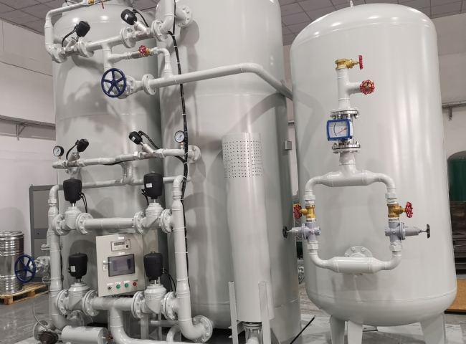
Suzhou Schitt has installed a nitrogen generator for annealing furnaces with a purity of 99.5%， a working pressure of 6 KG/CM2 and an annealing volume of 43 m3/h.
The Schitt nitrogen generator technology used for annealing is heated to and maintained at a suitable temperature and then cooled at a suitable rate to reduce hardness， improve machinability， promote cold working， produce a desirable microstructure or obtain desirable mechanical， physical or other properties.
Seagate annealing can be performed in a variety of different furnace atmospheres， depending on the material involved， including combustion products， nitrogen， nitrogen/hydrogen mixtures， exothermic and endothermic gases， dissociated ammonia (or dissociated ammonia diluted with nitrogen)， hydrogen， and vacuum.
Other generic names and related topics are listed below.
Isothermal annealing
Subcritical annealing
Process annealing
Softening stabilization
Recrystallization annealing
Spherical annealing
Suzhou XITE sells a range of products for annealing furnaces
MODEL | CAPACITY m3/h
XTFD-40-50 | 43 m3/h

