6 m3/h hydrogen generator for generator cooling used in power plants

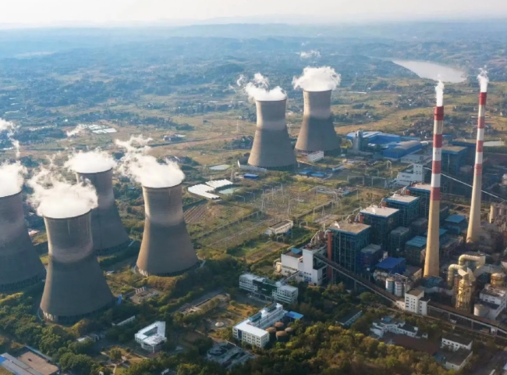
Did you know - hydrogen is widely used in power plants?
If you guessed that it is used to generate electricity， then sorry， it is not.
However， it is used in the process of generating electricity. Hydrogen is an effective coolant in generators. Power plants must maintain optimum gas purity and pressure inside the generator housing to ensure power generation efficiency， operational safety and equipment reliability.
In cooperation with Suzhou XITE， a world leader in hydrogen generation equipment， XITE has supplied several on-site hydrogen generation systems to power plants throughout China. The complete power solution for one power plant uses PEM technology to generate hydrogen， professionally maximizing generator capacity， extending generator life， and reducing overall costs for power plants worldwide.
Power plants without on-site hydrogen generation systems must obtain hydrogen in cylinders from outside vendors. This is not only inefficient， but also carries a high risk due to the frequent handling of cylinders. Each time a cylinder is connected and disconnected from the manifold， the risk of hydrogen leakage becomes apparent.
Our customer in northern China installed 1 hydrogen plant from Seagate in Suzhou， supplied by Seagate. The hydrogen equipment was installed inside the building with the advice and technical assurance of XITE. This is actually a safe practice for proton hydrogen generators， as the hydrogen inventory on the system is minimal and there is no need to store hydrogen. Hydrogen production from the Proton Field Generator is on demand.
Once the customer connects the hydrogen generator to a common hydrogen head line supplying hydrogen to the 4 turbine generators (TG)， the hydrogen generator starts producing hydrogen on demand for each turbine generator. The customer is now also able to monitor their hydrogen production as the complete operational data of the generators is brought to their central control command center. With the ability to study trends in hydrogen production， the customer is now able to react proactively if there are any deviations from the standard， thus highlighting any excessive hydrogen consumption by the TG， and take corrective action for any malfunctions in their generation equipment and machinery.

