Nitrogen injection for more efficient oil recovery technology and systems

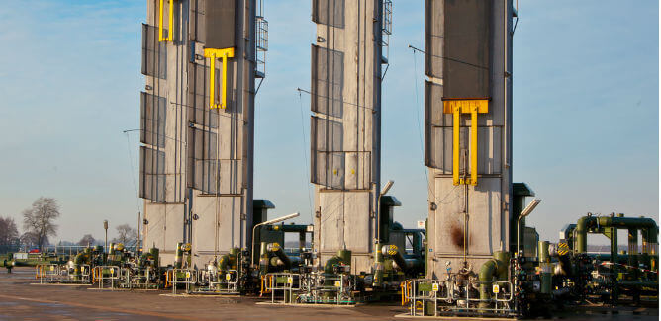
A typical oil and gas well life cycle is marked by a series of concerted efforts aimed at achieving optimal hydrocarbon recovery. Different technologies and techniques are used in several stages， depending on the age of the well， the unique characteristics of the formation and cost considerations.
This paper will provide an overview of the various stages of oil and gas production and explore the application of nitrogen injection to enhance oil recovery.
Primary Oil Recovery Stage
Primary oil recovery begins at the final stage of completion operations - after the newly drilled wellbore has been cased and cemented and a production tree has been installed at the wellhead. During this stage， engineers use pumping operations and natural formation pressure to flow oil and gas to the surface.
Secondary Oil Recovery Stage
After the well has produced for a period of time， the initial formation pressure drops. At this point， the secondary oil and gas recovery stage becomes critical to increasing production. For further recovery， the operator "sweeps" the hydrocarbons toward the production well by injecting water or gas into the target reservoir through a nearby injection well.
Improving Hydrocarbon Recovery
Primary oil and gas recovery methods release only about 10% of the initial oil (OIIP)， while secondary recovery efforts yield an additional 20-40%. As a result， a significant amount of oil remains in the formation until more advanced recovery methods are employed.
Collectively， these methods are known as enhanced oil recovery (EOR) techniques.
What is EOR?
As wells age， secondary recovery techniques become infeasible in maintaining production. This is because the remaining oil is trapped in the low permeability portion of the reservoir with irregular faults.
Enhanced oil recovery techniques attempt to artificially alter reservoir properties to restore formation pressure and increase oil discharge. If done properly， enhanced oil recovery efforts can recover up to 75% of the return on oil investment and increase existing production by 200-300%.
Different methods of enhanced oil recovery
Although the industry currently employs different technologies， EOR efforts can be divided into three main categories.
Chemical injection
Thermal injection
Gas injection
Chemical injection
Chemical flooding or injection uses chemicals such as surfactants and polymers (long chain molecules) to improve the flow of oil and gas by reducing the viscosity of the oil. For example， chemicals such as liquid carbon dioxide can be used to repressurize ultra-deep wells and reduce the surface tension of crude oil.
However， chemical injection is an expensive process that accounts for only a small fraction (<1%) of EOR work in oil and gas recovery in the United States.
Thermal Injection

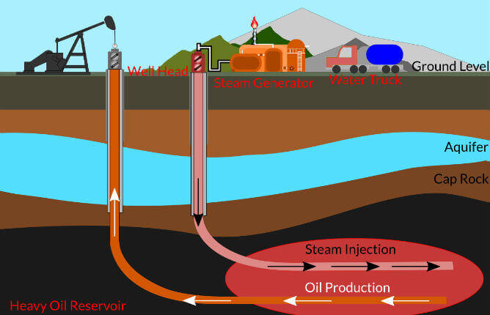
Thermal oil recovery interventions involve increasing the temperature of the oil-bearing portion of the reservoir to reduce the viscosity of the oil and improve its flowability. For thermal perfusion， water， steam or other high-temperature fluids are injected into the formation to improve its permeability and thereby allow oil to seep out.
As with chemical perfusion， thermal perfusion is an expensive process. It also poses safety and regulatory concerns for the industry because it can irreversibly alter the structure of subsurface oil wells.
Gas injection
In gas-injected EOR， nitrogen， carbon dioxide or natural gas is injected into the reservoir to improve or stabilize production. Gas injection improves the recovery of natural gas by expanding it， and improves the recovery of crude oil by dissolving it in the oil to reduce its viscosity and improve flowability.
Let's take a closer look at the use of nitrogen injection in oil wells.
Nitrogen Overlay
For decades， the industry's major oil and gas operators have explored the feasibility of using nitrogen injection for oil recovery due to its highly compressible nature， inert chemistry and reasonable cost of generation (the feedstock is atmospheric air).
Nitrogen is used in EOR through "miscible displacement" or "miscible flooding" - a process that improves the mobility of hydrocarbons by reducing the interfacial tension between oil and water.
How Nitrogen Replacement Works
In nitrogen injection， N2 at the appropriate minimum miscible pressure (MMP) is injected into the reservoir to release hydrocarbons trapped in the formation.
At very high pressures (about 15，000 psi)， N2 forms a miscible slug that sweeps hydrocarbons out of the hard-to-reach portions of the reservoir and pools them together， which are then pumped to the production well for collection. This process can recover up to 60% of the OIIP.
Advantages of nitrogen injection
Nitrogen injection is one of the more popular EOR technologies because it is cost effective and sustainable. A single railcar (nitrogen storage and transport unit) can hold up to 1.2 million standard cubic feet (SCF) of liquid nitrogen.
Another advantage of using nitrogen injection for enhanced oil recovery is its inert chemical properties. Nitrogen prevents downhole flaring of flammable gases and， unlike carbon dioxide， has no corrosive effect on pipelines.
Nitrogen Injection Systems
The nitrogen injection system is all the equipment required to perform nitrogen injection. An important component of the nitrogen generation system is the nitrogen generator (PSA nitrogen machine， nitrogen equipment) - used to generate on-demand nitrogen from the atmosphere by cryogenic fractionation.

