Inerting of coal mills， silos and bag filters in the cement industry

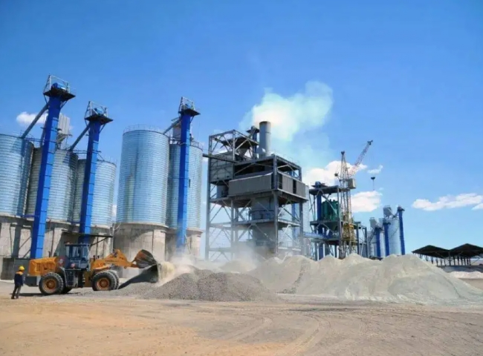
Suzhou XITE is a turnkey designer， manufacturer and supplier of gasification systems for coal mills， silos and bag filters in cement industry production. Our systems consist of nitrogen generator systems， nitrogen storage systems and nitrogen inerting systems.
Combustion， a high temperature exothermic oxidation reaction between fuel and oxidizer， means that combustion requires oxygen， fuel and heat. We also know that the limiting oxygen concentration (LOC)， also known as the minimum oxygen concentration (MOC)， is defined as the limiting concentration of oxygen below which combustion is not possible.
According to the flammability diagram， we can find the limiting oxygen concentration for certain processes. By limiting the oxygen concentration we can control the combustion and by inerting the nitrogen we can control the limiting oxygen concentration and thus reduce the possibility of combustion.
The above principle is used to design nitrogen inerting systems (inerting systems) for coal mills， silos and bag filters in the cement industry Suzhou XITE designers， manufacturers and suppliers of the entire nitrogen inerting system including the following items

Nitrogen generation system
Nitrogen storage system
Nitrogen pressurization system

