Nitrogen generator for food and beverage industry

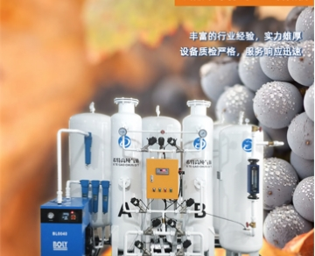
Nitrogen is an important application of packaging in food and beverage industry. It helps to prevent food deterioration， helps to maintain the freshness of foods such as fruits， and significantly prolongs the shelf life of various foods and beverages by preventing oxidation.
The uninterrupted nitrogen supply requires regular replacement of nitrogen cylinders， which will make the operation cost very large. If you install Xite intelligent on-site nitrogen generation system (PSA nitrogen generator)， you can not only save a lot of money， but also allow your factory to produce your own nitrogen on site according to your needs.
If the current nitrogen generator is installed in the factory， there is no need to worry about the need for continuous， and strictly check whether the nitrogen supply is sufficient. Once there is a handover problem， the production line will be shut down. When you have your own on-site nitrogen generator for food production， you can rest assured that your nitrogen supply will never stop， let alone more labor costs， nitrogen transportation costs and other expenses.
Role of nitrogen production in food and beverage industry
Nitrogen can play an important role in food and beverage packaging industry and food transportation industry.
By reducing the oxygen environment (map) of food storage， nitrogen is injected directly into food and beverage packaging to prolong and maximize the shelf life of products. Map is a particularly beneficial process for packaging high-fat snacks such as potato chips or dairy products such as cheese， which can prolong the shelf life of products.
Storage of beverage products such as fruit juice and wine in containers containing nitrogen in the top space of the package to prevent oxidation (contact with oxygen in the air) will also greatly extend the shelf life.
Nitrogen will help to keep fresh fruits and other products on long-distance transportation ships， and help to reduce spoilage of fruits.
Hitler nitrogen system produces food grade nitrogen， which can maximize the shelf life of food and beverage products. The on-site nitrogen generator greatly reduces the nitrogen cost related to map of food and beverage production companies.
Application of nitrogen in food and beverage industry
Xite provides food grade nitrogen generators for the following food and beverage industries:
? snack manufacturers of potato chips or other related snacks require a nitrogen purity rating of more than 99%
? beverages requiring 99% + nitrogen purity， such as fruit and vegetable juices
? coffee packaging lines that require 99% + nitrogen purity grades for whole beans， ground coffee and espresso bags
? modified atmosphere fruit storage requires 97% - 99% nitrogen purity grade to allow fruits and vegetables to mature and mature at a controllable speed
? any other food manufacturer that uses the map process to prevent deterioration， maintain flavor， maintain freshness and maximize the shelf life of the products they produce
The on-site nitrogen generator helps to reduce the production costs related to map， so as to improve the bottom line of manufacturers. Your customers will be happy because the products you offer them will be fresher and have a significantly longer shelf life， which will reduce expensive waste and improve their profitability. This is a win-win proposition for all parties!

