Combined Blowing Process in Converter Steelmaking
During the oxygen (O2) blowing process in a top-blown converter， chemical composition and temperature inhomogeneities are created in the molten steel due to the lack of mixing in the steel bath. There is a relative dead zone directly below the converter injection chamber. The need to improve the top-blow converter steelmaking process led to the development of the combined blowing process.
The combined blowing process， also known as top-bottom blowing or hybrid blowing process， is characterized by both a top-blowing lance and a method of achieving stirring from the bottom. The differences in the configuration of the hybrid blowing are mainly in the bottom spout or purge element. This ranges from completely cooled spouts， to non-cooled spouts， to permeable elements. The need for a bottom mixing system is necessary to produce a range of high quality and demanding steel grades， and is critical to the economics of the process. Therefore， the proper function of stirring must be ensured throughout the operation of the basic oxygen converter (BOF). Figure 1 shows the steelmaking process with top blowing and combined blowing.

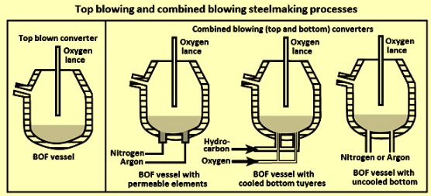
Figure 1 Top-blowing and combined blowing steelmaking processes
Currently， top and bottom combined blowing converters are commonly used in primary steelmaking plants. In a combined blowing converter， the mixing and stirring of the melt pool is forced by an oxygen injector blowing from the top and an inert gas stream from the bottom， which allows for high mixing efficiency of the melt pool. In rare cases， O2 is also injected from the bottom along with concentric double-tube spigots to control the temperature at the spigot exit and the wear at the bottom. However， since inert gas purging usually provides a higher control of wear， purge element and bottom life， most converters are equipped with bottom stirred gas purge plugs.
The first commercially accepted combined purge practice was the LBE (Lance Bubbling Equilibrium) process developed by ARBED-IRSID. This process is more closely related to the BOF process， as all oxygen is supplied from the top gun. The combined blowing aspect is achieved by a set of porous elements mounted at the bottom of the converter through which argon (Ar) or nitrogen (N2) is blown. In the LBE process， N2 gas is typically used almost exclusively for the majority of the blowdown， ranging from 3 normal cubic meters per minute (N cum/min) to 11 N cum/min. However， Argon is used for stirring later in the blowdown when N2 uptake can be problematic. In addition， Ar is used almost exclusively as an inert gas for post-blowing stirring， when the rate increases to between 10 N cum/min and 17 N cum/min. Figure 2 shows an LBE converter with a bottom-blowing element.
Bottom stirring using inert gases， such as N2 and Ar， is widely used to improve the mixing conditions in BOFs during the co-blowing process. The inert gases are introduced to the bottom of the furnace via a permeate element (LBE process) or a pot nozzle. In a typical practice， N2 gas is introduced through the vent or permeability element during the first 60% to 80% of the O2 blowdown， while Ar gas is turned on during the last 40% to 20% of the blowdown. The rapid evolution of CO during the first half of the O2 blowdown prevents the absorption of N2 in the steel. A cross-section of the porous element is shown in Figure 2.

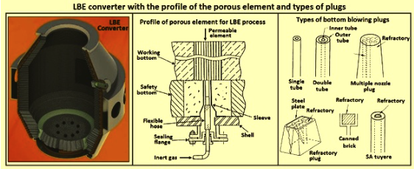
Figure 2 LBE converter with porous element profile and type of plugs
Bottom build-up and subsequent loss of porous elements are the main problems associated with this process. Difficulties in maintaining LBE element operation led to the application of non-cooled water ports. Here， O2 is delivered through a lance at the top， while inert gas is introduced into the melt pool from the bottom of the converter through elements of tubular design， which typically consist of six small tubes set in a refractory matrix. Due to the large cross-sectional area， a large flow rate needs to be maintained to keep the spout running.
Bottom plug/nozzle configuration
The initial development of the combination blow was essentially based on three types of bottom plugs used for bottom blowing. First， there was a refractory element that behaved much like a porous plug. This device is made of compacted bricks with small slits. As with most blowers， it requires sufficient gas pressure to prevent penetration of the steel. This device has more penetration power than the porous plug. Second， an uncooled tuyere is used to introduce a large amount of inert gas into each nozzle. This results in a localized vigorous agitation that can penetrate the pile more easily. Air or O2 cannot be used because without coolant， the heat generated makes the life of the pusher too short to be practical. The third type is a completely cooled pusher. Here inert gas or oxygen can be blown， causing very strong agitation with little or no problem of penetrating the bottom pile. In all cases， the gas line passes through the furnace trunnion， using rotary joints or seals to allow full rotation of the furnace. Figure 2 shows the various types of bottom blow plugs developed for co-blowing.
The current design status of plugs for inert gas bottom blowing is based on the single-hole plug (SHP) design and the multi-hole plug (MHP) design. These plug designs have been established as widely accepted as the most advanced bottom-blow plug designs.Both SHP and MHP purge plug designs use flow-rate optimized pipe diameters and pipe counts. However， the MHP for inert gas bottom blowdown is preferred. both types of SHP and MHP design purge plugs are based on magnesium carbon (MgO-C) refractory materials， which are typically made of 100% high grade molten magnesium， high grade graphite， optimized particle size distribution， and sometimes additives.
Efficient purging is the goal of all gas purge plugs in the BOF shop until the end of the BOF lining activity， which is influenced by the range of gas flow rates applied， the plugging potential and the wear rate under specific process conditions. The highest safety standards are a fundamental requirement for bottom purging.
Plugging potential - Reduced availability of the purge plug due to bottom buildup is often the cause of low purge efficiency. This increases the cost of the deoxidizer， reduces the yield and leads to a lower purge efficiency. The main causes of clogging are bottom buildup due to very viscous slag or high sparging frequency， problems with the inert gas supply or inappropriate purge plug design. While high gas flow rates through the SHP can help reduce the potential for plugging at low sparging rates， high sparging rates with potential bottom buildup or inadequate inert gas supply can lead to deep penetration of the SHP with a very low probability of reopening. However， the purge efficiency of the MHP is enhanced by many pipes with flow-optimized quantities， diameters and alignments. reopening rates of the MHP are reported regularly and are not susceptible to fluctuations in gas pressure and inert gas supply.
Safety - MHP's are generally designed with the highest safety standards. The gas piping is pressed directly into the MgO-C brick. If the gas supply to the MHP is reduced or zero for any reason， steel penetration applies only to a few millimeters of the purge plug. The risk of steel penetration into the MHP is minimized.
Blowdown characteristics and wear rate - The flow regime of the SHP is in the transition zone between bubbling and jetting， or completely in the jetting zone， resulting in a large amount of gas above the single tube， which subsequently decays into smaller bubbles with a larger size distribution. This flow regime is characterized by increased wear rates， e.g.， 0.4 mm/therm to 0.7 mm/therm. the MHP design provides a more suitable bubble distribution with a higher percentage of small bubbles above the purge plug. The higher specific surface of small bubbles increases the gas purification and metallurgical efficiency. Wear rates are typically lower due to reduced backlash phenomena and turbulence at lower gas velocities. Figure 3 shows the bubble evolution in the SHP and MHP with water models.

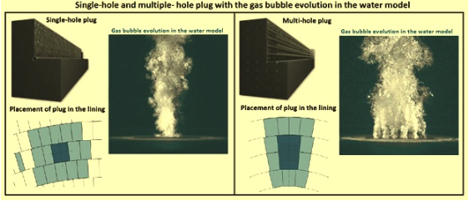
Figure 3 Model of bubble evolution of SHP and MHP in water
The process of combined blowing
In the combined steelmaking process， the O2 required for steelmaking is blown through the top-mounted lance， while the inert gas (N2 or Ar) required for the bottom stirring process is introduced into the melt through the bottom stirring brick to improve the process conditions by optimizing the mixing. The flow rate and type of stirring gas depends on the process stage and steel grade. Due to bottom stirring， the equilibrium state of the metal slag can be approached faster and better. The equilibrium and mixing time depends on the type， number and position of stirrers as well as the flow rate. Stronger stirring shifts the thermodynamic equilibrium to the desired direction and reduces the mixing time. A shift from N2 to Ar is usually required， depending on the final steel chemistry. As the central part of the bottom stirring system， the valve station allows individual flow control for each individual blowing plug.
As in the top blowing process， O2 is injected into the steel bath via a porous lance during the combined blowing process. Metal droplets are created as a result of jet impact and gas flow shear action， with the jet impacting the metal surface in the impact zone and the gas being deflected upward. The effect of this jet fluid interaction is described by three modes， namely (i) depression， (ii) splash， and (iii) penetration.
The number of iron droplets splashed into the gas and slag affects the metal yield， refractory wear and decarburization progress. The properties of the gas and liquid have an effect on the depression depth of the melt pool， with the critical depth marking the onset of sputtering. The sputtering increases to a certain jet momentum， beyond which it decreases. The direction of sputtering depends on the angle of the nozzle， the height of the nozzle， the profile of the jet cavity estimated from the depth and diameter， and the overlap of the O2 jets.
Many experiments have been conducted to modify the tip of the gun in order to control splash or spatter in converters. Proper design of the nozzle diameter and tilt angle is important for the optimal pressure distribution of the O2 jet. Different studies have shown that in BOF converters， top blowing plus bottom stirring of the converter tank gives better performance in terms of splash and spatter than top blowing only.
Various methods of bottom-blowing agitation have been used. A ceramic plug embedded in multiple small tubes or multiple slits is used in the bottom cutout. The mixing is carried out by means of special refractory stirring elements or by means of small unprotected air outlets arranged in the bottom of the converter.
The bottom blowing process effectively raises the melt pool height and shows a different refractory wear profile compared to the wear profile obtained with the top blowing BOF converter. In this type of process， wear in the converter and surrounding area is often severe and requires the use of erosion-resistant， high-density materials to resist the turbulence of the steel.
Combined blowing processes use expensive gases (O2， Ar and N2) and the accurate measurement and totalization of these gases contributes to economic operation and strict quality control by using these values to generate daily reports for management control. In order to agitate the converter tank， Ar or N2 gas is injected through a number of agitation plug bricks at the bottom of the converter. The total flow rate and gas type for each sequence step is predetermined by the loading menu of the current blowing. The total flow rate is equally distributed to a number of controllers， one for each stirrer brick， to maintain uniform distribution and to become a remote set point for the controller. The measured flow rate is mass compensated according to the temperature and pressure of each mixing plug brick and gas type and is input to the control module. 4-20 mA control output then modulates the position of the control valve.
If the mixing plug brick is covered with heavy slag， the pressure downstream increases. If it increases beyond a preset limit， the control changes from flow control to pressure control， and the control valve then responds to a different control algorithm. When the pressure decreases (less than a hysteresis value)， the control reverts to flow control. The switch between control modes is automatic， as the inactive loop tracks the output of the active loop.
To optimize gas consumption and flow control range， an additional inlet pressure control is installed. The combination of pressure control of the inlet line and separate flow control of the stirring line maintains a constant flow to the individual stirrers， thus avoiding clogging of the porous plugs by sticky slag. Appropriate instrumentation provides the operator with an indication of the porous plug condition. The reliability of the process is very important. Fail-safe concepts are usually provided for the feed line (gas switching in case of low inlet pressure) as well as for the individual streams (fail-safe opening in case of media and power failure). Figure 4 shows a schematic of the co-blowing process.

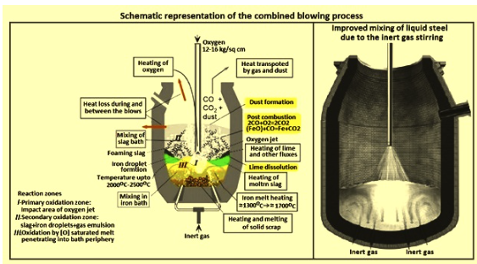
Fig. 4 Schematic diagram of the combined blowing process
The converter bottom mixing system is controlled by a PLC (Programmable Logic Controller)， which can be installed as a stand-alone unit with a separate HMI (Human Machine Interface) station， or provided for integration into a new or existing network. Operation requires flexibility. Depending on the selected steel grade， the software follows a stirring pattern of Ar and N2 flow rates throughout the heating process (setpoint parameter table) as a function of the total oxygen blowing volume. Depending on the field signals， setpoint changes and control actions are performed in automatic mode， without operator interaction.
During tapping， de-slagging and charging， a predetermined flow rate is ensured to reduce refractory wear and increase the service life of the porous plugs. Stirred plug bricks are designed to ensure long service life through low erosion rates， advanced flaking resistance and flexible brick lengths.
The position of the mixing plug brick relative to the O2 injector is very important for the effectiveness of the bottom mixing system. In order to optimize the position of the stirrer plug bricks， the main points to be considered are (i) the influence of the O2 jet under various process conditions (e.g. variations in head design and head height， etc.)， (ii) the aspect ratio of melt height to converter diameter， and (iii) the effect on refractory wear. Considering the complex conditions of BOF converters， the latest CFD (Computational Fluid Dynamics) simulation techniques are usually used to optimize the position of the stirring plug bricks.
The latest development in this field is the patented alternate stirring technology. In the practice of alternating stirring， groups of stirring elements are controlled in alternating high and low stirring gas flow rates. Statistical evaluation of the process results of several activities following the implementation of this technology in a converter plant showed the possibility of reducing argon costs by 30% without negatively affecting the metallurgical results.
Metallurgical effects of combined blowing
The blowing pattern， especially the number of plugs， the flow rate， and the type and quality of the blowing gas have a significant impact on the metallurgy of the BOF. These parameters must be strictly coordinated， otherwise the process will be out of control and the desired metallurgical results will not be achieved. The following metallurgical effects of combined blowing gases are shown
Carbon/O2 - The kinetics of decarburization is improved due to bottom blowing， so that the carbon (C) content is low at the end of the blowing and excessive oxidation of the steel does not occur. The indicator of efficient purification performance is the [C]x[O] product， which is much lower compared to a converter with top blow operation， with an average range of 0.002 % to 0.0025 %. Due to the non-equilibrium conditions in the steel during refining， there are also non-equilibrium conditions between the slag and the steel.
With a proper bottom blowing procedure， the reaction can be closer to equilibrium at the end of the blowing， thus enhancing the decarburization effect. This effect is further enhanced by the duration of the later stirring. The carbon content of the refractory lining is also an important parameter for the lowest carbon content.
With reference to a converter with top-blow operation， the lower dissolved [O] content at the same [C] level at steel discharge results in the lowest consumption of deoxidizer in the ladle. There is also an opportunity to release or save expensive RH (Rurhstahl Heraeus) degassing treatments because of the lowest refining levels at steel discharge.
Iron yield - Bottom blowing， hot metal composition ([Si] content)， slag practices and blowing procedures influence the iron oxide content in the slag and thus the chemical reaction potential between slag and liner as well as the effectiveness of post mixing. Compared to top-blown converters， bottom-blown converters are characterized by a lower iron content in the slag and a lower slag volume. In addition， the level of FeO in the slag at steel discharge depends on the dissolved C in the molten steel.
Manganese (Mn) - at the same C level at steel discharge， the Mn yield is higher than in the conventional top-blown converter process. In this respect， depending on the steel grade， the secondary metallurgical alloy requires less Fe-Mn. Therefore， the adjustment of the Mn level is better controlled.
Phosphorus (P) - bottom-blowing is characterized by a better absorption of P2O5 in the slag and faster lime dissolution. According to the iron droplets ejected during the BOF converter refining process， especially in the hard-blowing stage， the slag temperature formed is higher than the melt pool. This leads to weaker conditions for dephosphorization. With blowing， the slag temperature is considerably lower due to good pool agitation and a better temperature balance between slag and molten steel.
Influence of post-stirring - The main purpose of post-stirring is on the one hand to achieve the lowest C and P levels at steel exit and on the other hand to quickly and precisely adjust the exit temperature (cooling effect). Cleaning time and intensity are two decisive parameters for achieving a specific element level. The post-stirring brings the dissolved C and O2 in the steel closer to equilibrium， thus greatly enhancing the decarburization effect. Post-stirring leads to cooling of the molten steel and is enhanced by the additional addition of BOF slag. This means that the distribution of P is enhanced at factor 3 and the level of P drops to 0.005 % during tapping.
Effect of purge plug arrangement and number of plugs - The purge system influences the equilibrium conditions of the molten steel during the refining process and thus the metallurgical results. Bottom blowing allows to get closer or closer to the equilibrium condition at the end of blowing. The results of decarburization and dephosphorization have been greatly improved. In order to ensure the effectiveness of the blowing， the parameter Rp has been established. rp describes the ratio of the actual conditions to the equilibrium conditions. If the equilibrium condition is reached， the parameter Rp is 1. An increase in the number of plugs means an intensification of the bath agitation and therefore a value of Rp closer to 1. Figure 5 shows the consequences of various plug arrangements and numbers on the approach to equilibrium (defined by the purging parameter Rp).

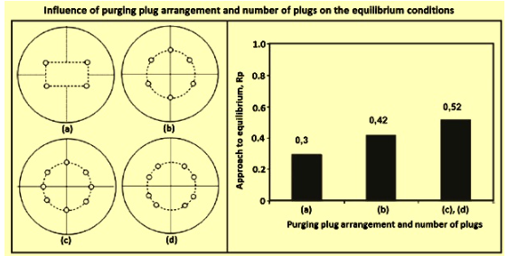
Fig. 5 Influence of the arrangement of cleaning plugs and the number of plugs on the equilibrium conditions
The indicator of bath agitation or mixing is the relative mixing time. A decrease in mixing time implies an improvement in bath mixing/kinetics， which accelerates the chemical reaction (shortens the reaction process). Another parameter describing the kinetics of the water bath is the mixing energy. The mixing energy relates to the lance height， geometry， blowing method， bath layer of liquid metal and， for top-blowing converters with bottom-blowing systems， to the blowing flow rate.
The keys to a successful bottom purge system are the purge pattern， the number of plugs， the wear rate and the availability of each plug. The arrangement of purge plugs is almost irrelevant and is only one design element.
Influence of purge intensity - The level of purge intensity plays a decisive role in obtaining the lowest [C]x[O] product and iron loss in the steel bath. The lowest level of purging leads to a significant reduction of [C]x[O] product， especially below the set flow rate of 0.06 N cum/t min.
Operational benefits - The top blow process with a bottom blow system is also reflected in less turbulent refining and therefore less tilting， resulting in higher yields. In addition， the total oxygen consumption is about 2% and the steel output temperature is on average 10 degrees Celsius lower compared to the conventional BOF process. This is the result of better bath mixing and homogenization conditions in the steel bath. The amount of lime charged is reduced by about 10 to 15 % compared to a converter with top blow operation.
Ideal switching point from nitrogen to argon
During the refining process， the nitrogen level at steel discharge can be flexibly adjusted by changing the switching point from nitrogen to argon and especially the purge flow. It is common practice to reduce the nitrogen flow rate at the beginning of refining and to increase the argon purge intensity significantly after the switchover. Therefore， in order to achieve the lowest [C]x[O] product， an intensive purge in the last third of the refining period is appropriate.
As a rule， the gas type and purge intensity do not have any influence on the N2 level in the melt until 25% of the refining process. Purging with argon at this refining stage is not cost effective and does not make sense. Argon is more expensive than nitrogen. In order to achieve the lowest N2 levels， it is necessary to switch from N2 to Ar between 25% and 50% of the blowing time. sluggish transitions， especially above 50% of the refining time， can result in very high N2 levels in the steel exit.
The introduction of bottom blowing significantly increases the splash in the lower part of the converter. At the same time， this reduces metal losses and cone deformation. The success of the combined blowing process depends on the effectiveness of the bottom stirring devices. These devices have to be reliable， cause effective stirring， have a reasonable service life and not be blocked during converter operation.
Slag sparging and combined blowing
Slag sparging is a proven technology for increasing the life of the converter movement to a very high level. After the steel is discharged， the slag in the converter is sprayed with N2 into different areas of the liner during a period of 2 to 5 minutes. In addition， there are practices such as slag coating and slag washing. This practice involves retaining a small amount of liquid slag in the converter after the steel is discharged. The slag is enriched with dolomite or raw dolomite. Afterwards， the converter is shaken several times to cover the bottom and adjacent areas with a thin layer of slag. Hot patching and shelling are other measures to improve the life of the refractory lining of the converter.
Slag sparging works best in creamy and sticky slags. However， sticky slag can cause a layer of slag to build up at the bottom of the converter， preventing the free evolution of gas jets from the nozzles/inserts， or even blocking them completely. This is usually not a fault of the bottom stirring system itself， but can lead to a significant deterioration of metallurgical results due to the unfavorable gas distribution.
Effective bottom stirring is not possible in the case of a slag layer covering the bottom stirring elements， because the gas cannot be injected as a directed jet stream. Instead， it creeps between the liner and the slag layer until it finds a crack to escape. In this case， the important stirring effect cannot be fully established. In the case of an extremely thick slag layer， the gas may even creep along the barrel to the upper cone or the mouth， showing no stirring effect and no metallurgical effect. This phenomenon is shown in Figure 6. It has been verified by the use of natural gas， which can be identified by the flame. It has been detected that the natural gas escapes in the area described. The left side of Figure 6 is showing the slag layer just covering the bottom. The right side shows the slag layer covering the bottom， the lower section and the barrel， which is produced by intensive slag spattering.

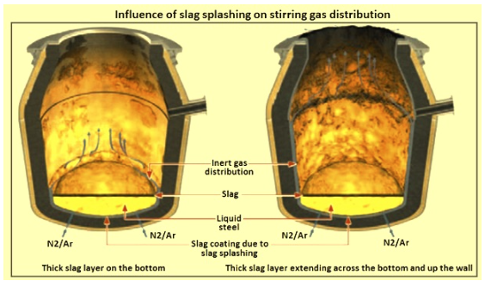
Fig. 6 Influence of slag splash on the distribution of the stirring gas
It can be seen that in extreme cases the inert gas is neither in contact with the melt nor in complete contact with the slag. Therefore， in order to maintain the functionality of the bottom stirring system， it is necessary to regularly control the bottom thickness and to start countermeasures early.
Advantages of combined blowing
The fundamental reason for implementing a bottom blowing system is on the one hand to improve metallurgical results and on the other hand to ensure the production of high-quality， economical O2 steel at the lowest possible cost. In BOF converters， the most important benefits of combined blowing converters over top blowing are (i) faster blowing cycles and thus shorter tap-to-tap times， (ii) shorter and faster slag formation and improved interaction between slag and steel (better conditions for scrap/melt addition melting. higher scrap/hot metal ratios)， (iii) reduced reblowing and improved composition and temperature hits， (iv) improved steel homogenization/mixing and temperature distribution， (v) improved accuracy in achieving specific compositions， (vi) improved process control (improved accuracy of steel output temperature and elemental content). (vii) improved steel and flux additions (less slag， less iron loss in slag and molten dust)， (viii) less spatter and slag spitting， (ix) lower (FeO)， [P] levels and [Mn] oxidation resulting in lower O2 consumption， (x) less iron oxide in the slag， (xi) improved blowing efficiency due to strongly enhanced melt stirring. (xii) lower final O2 content in the steel， thus requiring less deoxidizer (ferroalloys and aluminum)， (xiii) improved steel quality due to inert gas blowing at the end of the procedure reducing the gas concentration in the metal， and (xiv) improved refractory lining life by avoiding excessive heating of the iron oxide rich slag.
The disadvantages of combined blowing are (i) more complex converter equipment for the combined blowing process， which increases the cost of the shop， but this is compensated by the advantages mentioned above， (ii) the high cost of argon gas， which in many cases is attempted to be at least partially replaced by N2， and (iii) the availability of bottom stirring nozzles or bricks is often below 100% due to more severe brick wear compared to other converter liners.

