Supply of nitrogen generators for chemical overlay applications

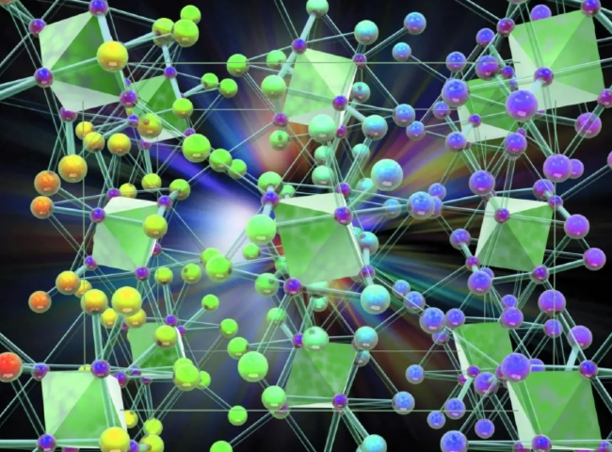
Seagate supplied a PSA nitrogen generator to a large chemical production plant.
The customer purchased the following specifications of nitrogen equipment from Seagate.

Technology: Pressure Swing Adsorption (PSA)

Capacity (nitrogen flow rate): 10 m3/h

Purity: 99.7%.
This is a complete turnkey project including a dedicated air compressor.
The customer， a large and well-known chemical manufacturer， was using our PSA nitrogen equipment to cap chemical storage tanks. These chemicals should not be exposed to oxygen， so the tanks are cleaned with nitrogen before filling with chemicals and subsequently the empty head space in the tanks is filled with nitrogen to avoid any contact of oxygen with the stored chemicals.
About XITE Corporation
XITE is a turnkey supplier of gas generation equipment for nitrogen， oxygen and hydrogen. In addition， we manufacture air， gas and liquid dryers and gas purification systems. XITE is the largest supplier of gaseous nitrogen， oxygen and hydrogen equipment in China. In addition to China， XITE regularly exports equipment to the Middle East， Africa， South East Asia and Europe.

