Introduction of nitrogen refilling equipment

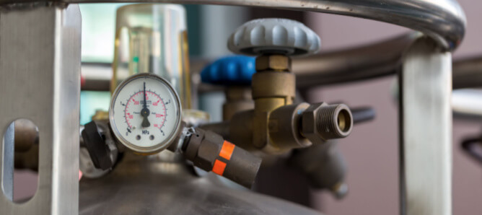
Spraying is essential for some industrial processes because it provides a variety of benefits， including reduced corrosion， contaminants and energy costs. In addition， the process requires high purity compressed nitrogen to minimize the concentration of oxygen in tanks and other industrial equipment. First， however， operators must determine and implement the ideal method to obtain nitrogen to perform the injection. This article provides an overview of nitrogen refueling， highlighting the different techniques for procuring nitrogen.
What is Nitrogen Injection?
Nitrogen injection involves the injection of nitrogen into the liquid phase via a diffuser. In other words， nitrogen injection is the passage of finely dispersed nitrogen through a liquid. In addition to reducing the oxygen content， nitrogen injection enhances biological and chemical reactions.
Metal storage tanks for several liquids， including water， are easily subjected to corrosion due to the high oxygen content. However， with nitrogen injection， these tanks can maintain a protective layer of nitrogen and eliminate dissolved oxygen and other reactive gases from the liquid， minimizing corrosion and contamination， and ultimately reducing production and operating costs in some industries.
What is the purpose of nitrogen booster equipment?
Nitrogen pressurization equipment is essential in several applications to meet consumer and industrial requirements. In general， the injection eliminates unwanted substances and unwanted chemical reactions with oxygen. In addition， operators ensure a steady supply of inert nitrogen for a variety of industrial processes by installing the ideal nitrogen injection equipment.
This typically includes a valve control system， a filling element， a nitrogen source and valves. The valve control system ensures a continuous supply of nitrogen to the tank or industrial process by automatically adjusting the nitrogen level to maintain a protective layer against oxidation. Thus， the system ensures the required nitrogen level during tank filling and emptying.
The spray elements are sintered stainless steel plates or rods that play a key role when spraying with nitrogen. These elements continuously purify the liquid (e.g. water) to achieve a minimum oxygen content， which in turn minimizes corrosion and enables anaerobic activity.
The plant operator achieves a corrosion-free and copper oxide free industrial process by spraying nitrogen into the plant. In addition， the reduction of copper， iron， oxygen and other reactive elements can lead to a significant corresponding reduction in energy costs. For example， conventional power plants require an auxiliary steam supply for the deaerator. However， with nitrogen injection equipment， these plants can be operated in an optimal manner and minimize the chance of tank contamination.

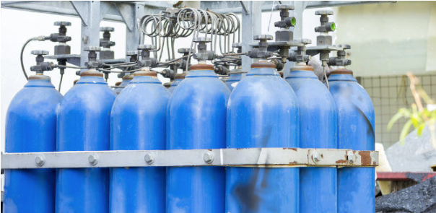
Industries that depend on gas addition
Nitrogen injection has many uses - from food processing， power generation， pharmaceutical and wastewater management， and N2 manufacturing to pH control. For example， in process operations in the power generation industry， nitrogen injection through demineralized and deionized water can greatly reduce damage caused by corrosion in boilers and feeder systems. As a result， overflows can improve the efficiency and cost effectiveness of the entire system.
In view of the food processing industry， operators spray gas into food and beverages， spray nitrogen and carbon dioxide into wines and juices， and blanket beverages during filling and shipping. In the food processing industry， gas injection can inhibit oxidation and replace harsh physical or chemical preservative methods.
In other industrial applications， operators can use gas injection for pH stabilization of processed water， contamination-free pharmaceutical processes， steam injection in pipelines， and dissolution of reaction gases into the liquid phase for further reactions such as fermentation， oxidation and ozonation.
Obtaining Nitrogen for Jet Gas
The source of nitrogen is a key factor that operators must consider in a jet gas application. Although 78% of atmospheric air is nitrogen， the gassing process requires high purity compressed nitrogen to achieve significant results. Some typical methods of obtaining nitrogen include
Nitrogen delivery
On-site nitrogen production
Nitrogen Delivery
Operators choose to deliver nitrogen through several media， including high-pressure cylinders， microbubbles and bulk liquid tanks. While high-pressure cylinders are not suitable for refilling due to limited storage capacity， resulting in inefficient processes， microbulk tanks can contain enough nitrogen for refilling. However， microbulk tanks can cause significant losses to the operator due to nitrogen evaporation.
On the other hand， bulk liquid tanks delivered by truck require large insulated containers for storage. The operator mounted these insulated containers on concrete slabs and protected them with fences. This additional infrastructure adds to the cost of the entire refueling process. Although nitrogen delivery for refueling gives the appearance of an endless supply of nitrogen and requires minimal maintenance， this method easily suffers from price and contractual inconsistencies.
On-Site Nitrogen Generation
On-site nitrogen generation involves the production of up to 99.999% pure nitrogen from a compressed air supply. Therefore， operators can choose an on-site nitrogen generator to produce nitrogen on demand at a lower cost， i.e.， about $0.15 per cubic foot (hundred cubic feet)， compared to a nitrogen delivery cost of at least $0.70 per cubic foot.
It is important to note that on-site nitrogen generators are temperature sensitive. Operators need to consider this factor when considering on-site nitrogen generators， as they require a weather-protected location. However， due to the low cost， high efficiency and consistent nitrogen supply， on-site generators are a better option than nitrogen delivery.
Visit Suzhou XITE Gases' industrial grade nitrogen generators
Suzhou XITE Gases is committed to designing， manufacturing and installing best-in-class nitrogen generation systems that meet consumer and industrial standards. We provide expertise to help customers select and build the ideal nitrogen supply solution for their gassing applications. We also distribute air dryers， pressurized air compressors， industrial air filtration systems and more.

