Advantech Air Compressor Frequency Control Solution
[System Overview]
Air compressor set is a necessary equipment for many enterprises. According to the site air conditions， the need to control the air compressor on and off (such as regular maintenance， failure emergency stop， etc.)， through the inverter to control the compression speed to adapt to the changing air conditions with the purpose of saving electricity. All these require sequential operation of the corresponding switches， valves and control of the inverter to complete. During operation， it is required to check the condition of the unit frequently， and emergency stop should be made when the temperature， pressure and rated current of the motor exceed the allowed value. Excessive pressure requires the inverter to reduce the motor speed and stop part of the air compressor if necessary. The drawbacks of all these human monitoring are: 24-hour monitoring personnel are easily fatigued， very unsafe， and wasteful of human resources. Therefore automatic intelligent monitoring solutions using IPCs are being widely used.
A mine site has three V-6/7 electric fixed water-cooled air compressor units， which are required to start and stop automatically by remote operation， stop automatically with abnormal parameters， and operate with frequency and energy saving. Due to the unstable voltage in the mine， especially the air compressor start-stop interference to the power grid， strong vibration， dust， harsh environment， the need for 24-hour uninterrupted work， to ensure the safety and stability of the system， the system control core using Advantech IPC Xiangjie I-P10S22， the overall solution is as follows.
[system composition]
A， to detect the point :
1， power signal detection equipment: detection of the main motor current 1 point， and the total of 3 points of the total power supply voltage 3 points.
2， pressure signal detection equipment: detection of level 1 cylinder， level 2 cylinder and storage cylinder pressure 3 points.
3、Temperature signal detection equipment: detecting the exhaust temperature of 1-stage cylinder， intake temperature of 2-stage cylinder， exhaust temperature of 2-stage cylinder， oil temperature， crankshaft bearing temperature 2 points， motor bearing temperature 2 points and cooling water outlet temperature 9 points.
Total: (1+3+9)X3+3=42 points
Second， the key equipment:
1， I-P10S22 industrial control machine: "Xiangjie I-P10S22" industrial control machine is a professional domestic industrial control machine design and production company Advantech products， by IPC-810A chassis， IPC-6113LP4 backplane， FSC-1622VDNA industrial-grade CPU long card， industrial power supply PS-270A and so on. 270A and so on， quality assurance， the system's security factor greatly improved.
2， PCI-64AD data acquisition card: 64-channel high-gain multi-function DAS card (PCI bus interface)， in this system as a 32-way differential analog signal for A/D conversion， responsible for quantitative data acquisition of the analog input signal at the detection point.
3， PCI-16P16R control card: is a 16-channel relay output and isolated small PCI bus digital D / I card， providing 16 relay outputs and 16 optical isolated digital inputs. The 16 relay outputs on the board are used to control the power switch or switch control equipment (such as cooling water pump switch， intake valve， exhaust valve switch， main motor on/off， etc.)， and the 16 optically isolated digital inputs are used to monitor the point of "switch signal" input (such as high temperature alarm point， pressure professional valve value， etc.).
4、Inverter controller: The operation is controlled by the industrial control computer， and the motor speed is changed by changing the output voltage frequency to change the compressor pressure speed.
[System block diagram]

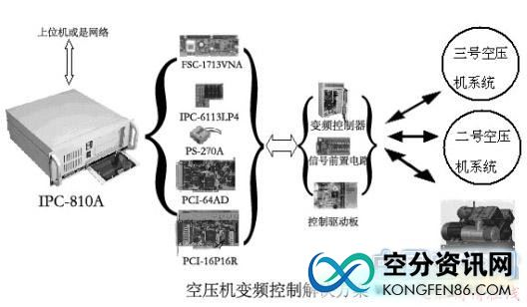
The block diagram of the system is shown below， the block diagram of the whole system is only a rough depiction of the system principle， the actual situation is more complex alignment.
[System Configuration]
1， Xiangjie I-P10S22: IPC-810A/IPC-6113LP4/FSC-1713VNA/P34 2.0G/256M/80G/PS-270A
2、PCI-64AD
3、PCI-16P16R

