300 m3/h nitrogen generator with deaeration system for bright annealing of copper and copper-nickel alloys

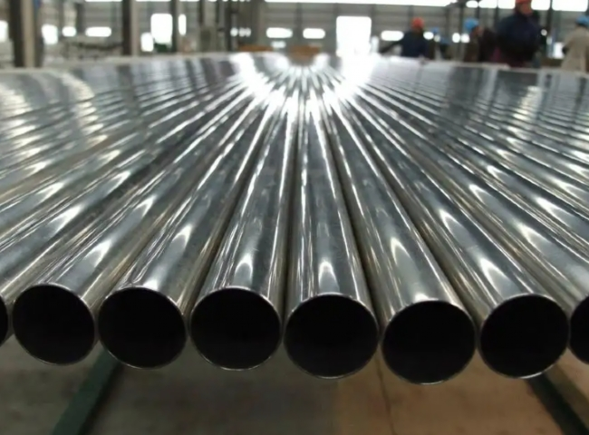
XITE supplied a nitrogen plant to a large Chinese manufacturer and exporter of seamless extruded copper， copper alloy products， copper-nickel alloys， Cunifor， aluminum brass， and Admiralty brass.
The customer needed nitrogen to anneal the copper.
The customer purchased the following specifications of nitrogen inert gas equipment from XITE.
Technology: High Purity Pressure Swing Adsorption (PSA) - with deoxidation system
Capacity: 300 m3/h
Application: bright annealing of copper and copper-nickel
In order to achieve a bright surface finish during the annealing of copper and brass products， the annealing process requires a highly reducing gas， hence the use of hydrogen. This poses a risk of explosion when hydrogen is combined with oxygen in the air in the right proportions. To overcome this problem， nitrogen was used for purification and safety to eliminate the possibility of mixing hydrogen with air.
This complete nitrogen generator is done on a turnkey basis and includes an air compressor， a large size nitrogen storage tank and a deoxidation reactor and dryer heater.
A similar case.
Over the past 30 years， we have supplied over 400 nitrogen generators to most of the major metallurgical heat treatment companies in China and overseas. More and more customers are choosing on-site nitrogen and hydrogen generators as a more cost effective solution.
About PSA Nitrogen Generators
For customers using nitrogen via cylinders， PSA nitrogen generators offer many benefits， including a significant reduction in the cost of nitrogen.PSA nitrogen generators are very low maintenance and allow customers to run 24 x 7 for peace of mind.PSA is a very mature technology and XITE is a professional manufacturer of PSA nitrogen generators in China， having supplied over 1200 generators worldwide.

