Application of industrial oxygen in water treatment

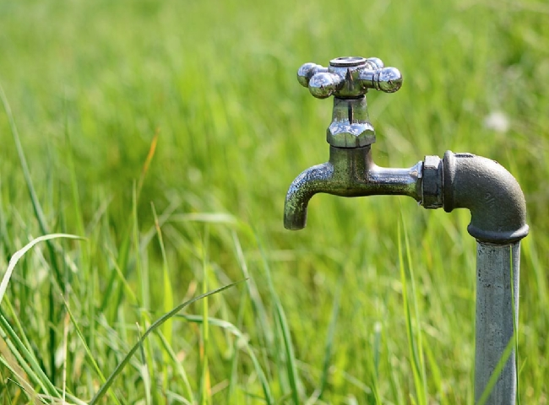
You may be wondering what water treatment this has to do with industrial oxygen， but the fact is that using an on-site oxygen generator can make their water treatment process more sustainable and efficient. Let's learn together why water needs to be treated and the water treatment process， and how industrial gases can play a role in purifying water.
The goal of water treatment
When we think of water quality， we usually think of drinking water， but water is more than just the water we drink. Wastewater， streams， lakes and other bodies of water all play an indirect role in our daily lives. Many challenges arise when trying to control water quality， such as natural disasters， rainstorms， recreational activities， fires and other water-related factors that can affect the purity of water.
When considering how to improve water quality， it all comes down to protecting the source of the water. To determine what should be done to protect the water， quality tests， analyses and benchmarks are set to assess where improvements are needed. Constantly monitoring and maintaining a good water quality will always be the main goal of the water treatment department.
Basic processes of water treatment
Through mechanical and chemical processes: water is treated to remove any contaminants and pollutants. There are a range of contaminants in water， including bacteria， organic compounds， fungi， minerals， metals and other unsanitary elements that can make us sick. That's why there are water treatment processes to recycle and clean our water.
Coagulation: Compounds are added to the water flowing through the treatment plant to remove dirt particles and other particles from the water. The added compounds act like a magnet， attracting the particles in the water.
Settling: Next， the "magnetized" particles sink to the bottom of the tank， allowing the water to filter to the next stage.
Filtration: The water then passes through a filtration process that further purifies the water through a biological process. This is accomplished by passing the water through a series of tanks containing sand， gravel and charcoal filters. These natural filtration methods are used in order to avoid the use of additional chemicals. These filters remove bacteria and any other smaller solid particles.
Disinfection: Typically， chlorine is added to disinfect the water to kill any remaining bacteria and microorganisms.
Storage: After the water is disinfected， it flows through pipes to your home or business.

Alternatives to chemical treatment. Aeration and Carbon Dioxide Purification
According to the American Chemistry Council， oxygen and carbon dioxide are most commonly used in water treatment processes for wastewater， drinking water and other water bodies such as lakes and streams. Recently， there have been new innovations to enhance the purification process by using carbon dioxide to create a chemical gradient， which helps to separate impurities that cannot be completely removed by traditional chemical processes.
Purification methods. Very often， chemicals such as chlorine are used in the disinfection phase of the water treatment process， but alternative methods have been developed to better disinfect the water using carbon dioxide. Steps 2， 3 and 4 of the above treatment process are all forms of water purification that can be expensive and may not remove minor impurities.
Researchers have discovered a way to use carbon dioxide dissolved in water， which essentially charges and separates microorganisms from the purified water stream. This process creates a chemical gradient in the water that helps separate 99.9% of the impurities. This process is more efficient in terms of energy savings， it is more effective and easy to produce on a large scale which can lead to lower costs.
In addition， high purity oxygen is used for aerobic digestion， oxygen enhanced aeration and odor control. Aeration is an alternative to chemical treatment of water and can produce the same water benefits as chemical treatment without adding additional chemicals to the water supply.
Aeration. The role of bacteria in wastewater is to break down organic matter and convert it to carbon dioxide and water. During the coagulation process， oxygen can be pumped into the tank to help the bacteria grow. Bacteria can break down organic matter on their own， but this process can take too long and can lead to the production of hydrogen sulfide， which eventually turns into methane. This is why aeration is such an important part of the water treatment process.
Through aeration， bacteria consume organic matter， which includes soil and other organic materials that animals live on. This process creates the magnetic effect we mentioned above， which attracts this material， which then sinks to the bottom of the tank. When oxygen is added to the water， this ultimately helps break down the particles in the water more efficiently and prevents hydrogen sulfide and methane gas from being produced in the water.
With these alternative methods of using industrial gases， water treatment can be more efficient and safer for those who consume or use the water to accomplish the end result. With these methods， there may be more opportunities in the future to be able to provide cleaner water to third world countries as scientists work to simplify the process and make it more cost effective.

