How is the filling of oxygen cylinders carried out?

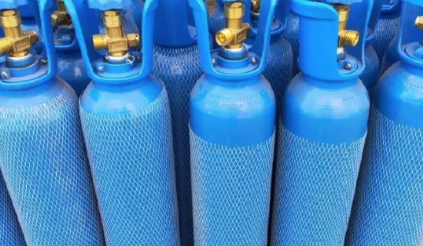
Gone are the days when you had to rely on cylinder suppliers to order medical oxygen for your hospital. Now， we've come up with a brilliant solution that will completely eliminate the effort of buying cylinders， storing and replacing them. Yes， you read that right. This technology will automatically fill your gas cylinders Want more surprises? Well， we've got you covered. A technology that will not only fill your gas cylinders automatically， but also supply oxygen through the pipes!" . Stay calm and don't faint. We will explain to you every detail of our technology. We know that medical oxygen is one of the most critical requirements for hospitals， so it shouldn't run out of stock. However， when using oxygen cylinders or liquid oxygen， hospitals should and have run out of oxygen. Imagine an unfortunate situation where your hospital is in desperate need of oxygen cylinders， but your area has suffered a natural disaster. In this case， the oxygen cylinder supplier may not be able to deliver oxygen cylinders on an emergency basis. In addition， oxygen cylinders need a place to be stored. However， the technology we propose does not require you to have much space. You just need to install the machine and you will not face a shortage of oxygen supply. If you want to know how the machine supplies oxygen through the pipes and how it automatically fills the oxygen bottles， then see the following article.
How does the machine automatically produce medical oxygen?
The technology we are talking about is known as a "medical oxygen machine". This machine takes the oxygen from the air and separates it from other gases. The separated oxygen is purified to varying degrees and then stored in a tank. From the tank， it will go directly into your hospital pipeline. The medical oxygen machine will be installed on your hospital premises and you will not have to rely on anyone for the supply. The machine can produce oxygen 24*7 and it is safe because it meets the standards set by the pharmacopoeia. You may be thinking about the cost of the machine. Well， to your surprise again， the return on investment for a medical oxygen machine is between 8-18 months!!! This means that the cost of the machine will be between 8-18 months. This means that the cost of the machine will be covered in a very short period of time and you can enjoy the benefits of it without having to pay any additional costs for more than a decade! If you want to learn about medical oxygen machines， click here.
How does the machine automatically fill oxygen cylinders?
The cylinders are filled automatically by a "high pressure oxygen booster". The oxygen booster will help to fill and store oxygen cylinders at 150barg pressure. The oxygen booster provides additional boost or pressure to the oxygen produced by the medical oxygen generator. Oxygen is stored in oxygen cylinders at high pressure， and to store something at high pressure requires external pressure. This external pressure is provided by the oxygen booster compressor. This is how oxygen cylinders are automatically filled. Now you may be wondering why you would need an oxygen booster to fill an oxygen cylinder if you are already using a medical oxygen machine. There are two main reasons for using an oxygen cylinder filled by an oxygen booster while using a medical oxygen machine. They are 1. It helps meet "peak demand" oxygen needs In a hospital， oxygen demand is not constant throughout the day. At some times， a large amount of oxygen may be needed， while other times there may be no need for oxygen at all. Situations that require large amounts of oxygen are known as peak demand. At this point， both the medical oxygen generator and the oxygen cylinder manifold may need to be opened to meet the medical oxygen demand for each bed. The oxygen concentrator continuously fills the oxygen cylinders at 150 bar， so high amounts of oxygen are met during peak demand with the help of the oxygen concentrator.2. 2. It serves as a backup An adequate oxygen supply is very important to the hospital. The slightest mistake can cause a very unfortunate situation for your reputation and a risk to your patients. Imagine if the power supply stopped for two days. This is rare， but it is possible. In this case， the oxygen stored in the tanks of the medical oxygen machine would run out within a few hours， and the additional oxygen needed would not be available to perform further procedures. But here， your other source of medical oxygen， namely oxygen cylinders filled by our machines， will meet the demand. Hospital pipelines use oxygen cylinders filled by medical oxygen generators as the primary source of oxygen. Oxygen boosters automatically fill the cylinders and can be used in such emergency situations. Now the question arises， what is the need to install a high compression oxygen booster when we can order some cylinders from a supplier? Well， you can order cylinders from a supplier， but there are more advantages to installing an oxygen booster. If you are interested in knowing this， please click here. Hopefully， you have learned the mechanics of how medical oxygen is supplied through the pipeline and how oxygen cylinders are filled. If you are interested in purchasing medium and large medical oxygen generators and high pressure oxygen boosters， then you are free to contact us.

