The application of nitrogen generator in the production of cable industry

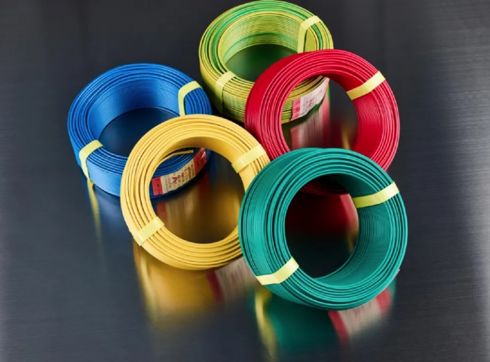
The cable industry and wire production are large global industries. In order to achieve their efficient industrial processes， both industries are using nitrogen. Nitrogen makes up more than three quarters of the air we breathe， and it is also an important gas used for commercial purposes in industrial production. As a result， more and more companies are turning to generating their nitrogen rather than buying it from third-party suppliers. We have been at the forefront of manufacturing nitrogen generators for the cable industry.
Why do cable manufacturers need nitrogen?
When manufacturing cables， air， humidity and oxygen molecules enter the coating material and the wire's coating. In the coating material， nitrogen is injected and injected into the wire. This creates a closed nitrogen environment， which prevents oxidation.
Tempering of copper wire
To improve flexibility and resistance， copper wire materials are tempered. During the tempering process， nitrogen is pushed into the furnace to prevent oxidation from occurring at the high temperatures generated within the furnace. The nitrogen gas successfully prevents oxidation.
Cooling and Heating
Air conditioning and industrial cooling and heating equipment use copper tubing. These copper wires are subjected to a leak test， in which nitrogen is used.
Coating of wires
Galvanizing is the immersion of iron in zinc liquefied at a temperature of 450-455°C. Here， the zinc is firmly bound to the structure of the iron， increasing its resistance to oxidation of the metal. The galvanized wire is removed from the zinc shower and then sprayed with nitrogen to avoid any residual liquid zinc on it. In this process， this method enjoys two optimal configurations. The thickness of the galvanized layer is uniform over the entire width of the wire. Along with this method， the piled up zinc material is returned to the bath and a lot of money is saved.
Curing and vulcanization applications
In their CCV line， nitrogen is used to cure the cable in the conduit. Nitrogen at pressure and temperature allows for cross-linking of the cable and also for subsequent cooling.
XITE has supplied over 25 nitrogen plants for CCV applications to a number of companies in China， Asia and the Middle East. From an on-site nitrogen generator， nitrogen is produced at a pressure of 5 to 7 bar and then boosted to a pressure of 25 bar by a booster compressor and stored in high pressure tanks as intermediate buffer storage.
XITE's nitrogen production systems are installed in numerous applications including chemical blankets， electronics， heat treatment， rapid prototyping， power generation， plastics and many more. These units eliminate the need to handle high pressure cylinders or liquid dewars and batch deliveries， providing an immediate return on investment.
Features of XITE Nitrogen generators for the cable industry
- The equipment uses a newly designed filling technology that extends the life of the molecular sieve to more than 10 years.
- Special bypass design ensures low energy consumption and big effect.
- Imported pneumatic valve ensures more stable performance.
- Computer operation， simple technical design and easy maintenance.
- Easy installation. No special foundation is needed， it can be installed on normal flat ground.
High voltage cables (33KV to 210KV) are manufactured worldwide under nitrogen atmosphere curing. XITE has supplied 25 nitrogen units for such applications in several countries in Asia and the Middle East.

