A medical oxygen machine used in a public hospital

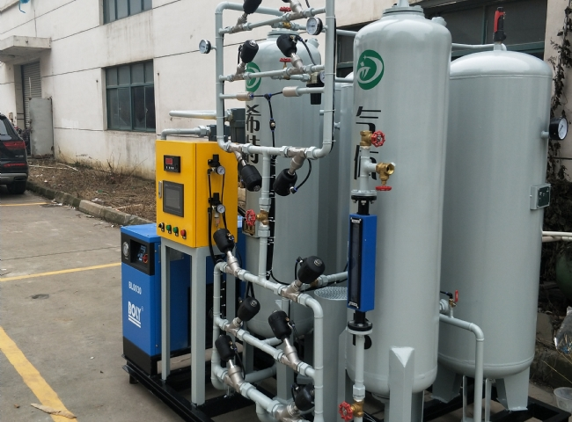
Providing quality care to patients is a top priority for all medical centers. In order to provide high quality care， hospitals need facilities that have high purity， uninterrupted delivery of medical oxygen. However， it is necessary to ensure a continuous supply of medical-grade oxygen while keeping operating costs to a minimum.
Most hospitals have adapted to this change to meet the soaring demand for high-purity oxygen. Hospital management has switched from cylinders to XITE medical oxygen generators to have an uninterrupted supply of high purity medical oxygen.
Independent production of medical oxygen can help save significant costs. The PSA medical oxygen generators produce the required quantity of medical oxygen at a purity of 93-95%， which meets the requirements of the Chinese Pharmacopoeia for medical applications.The PSA medical oxygen generators are equipped with purity monitoring equipment to ensure that the oxygen produced is within the acceptable purity range. According to the pharmacopoeia， the allowable range of oxygen produced by PSA is 93% ± 3%. If the oxygen purity falls below 90%， the gas generator stops immediately and the system automatically switches to a backup supply.
Our generators have helped customers significantly reduce operating costs and have proven to be a cost effective alternative to cylinders， liquid oxygen dew tanks and canisters. The cost of producing oxygen from ambient air is very low. Typically， the investment cost can be recovered within two years， thus contributing to the success of the organization.
Providing medical care is a sensitive task. It is a matter of life and death. Having a continuous on-site oxygen supply helps users avoid the risk of supply shortages and other risks associated with oxygen supply to medical facilities. Especially in remote areas， it is not easy to secure oxygen supply by delivering oxygen. On-site oxygen production ensures that users have a continuous supply of oxygen no matter where they are.
We have always been up-to-date on technology and produce on-site generator sets equipped with innovative and future-oriented technology. All our plants are meticulously inspected and controlled to provide our customers with a high quality service.

