Tank inspection of liquid oxygen prior to tank filling

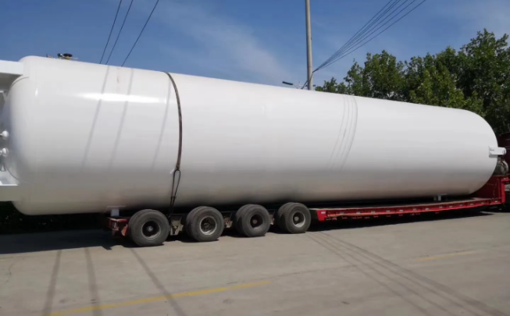
Before filling the tank， the liquid oxygen storage tank should be tested for gas tightness， blowing out treatment and inspection of valves and instruments before it is put into use. The following is a detailed introduction to the inspection work of liquid oxygen tanks before filling.
1、Blow off treatment. After the airtightness test is passed， the inner cylinder system of the storage tank should be blown out with dry and oil-free air. To remove the humid air， the dew point of the exhaust gas should not be higher than -40℃. Note that when blowing out， all external closures should be exhausted to remove mechanical impurities and moist air from the valves and pipes. After the system is blown out with dry air or dry nitrogen， the product gas should also be blown out until the purity of the discharged gas meets the requirements.
2、Inspection of valves and instruments. Before filling the cryogenic liquid， the valve must be carefully checked to see if it is in the correct state of opening and closing， the instrumentation is correct， otherwise it should be adjusted.
3、Gas-tightness test. Tank installation is completed， or the inner tube to restore room temperature， before filling the cryogenic liquid should be system gas tightness test， test pressure for the highest working pressure of the tank， test gas for oil-free dry air or dry nitrogen， the test time shall not be less than 4 hours.

