Nitrogen generators for the oil and gas industry

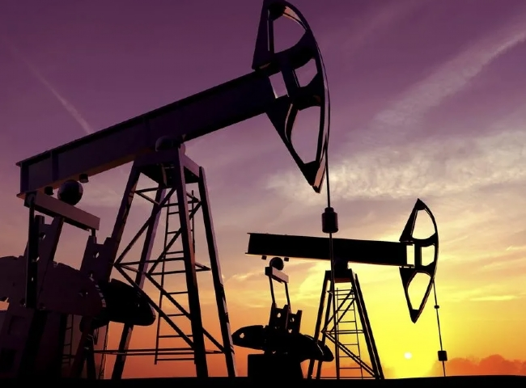
Content- #Nitrogen making machine， nitrogen generator， nitrogen making machine
Nitrogen making machine for oil and gas industry with 99.9% purity， 5KG/CM2 working pressure and 50 NM3/HR power.
Nitrogen is a colorless and odorless gas， a non-hydrocarbon inert gas with multiple functions in the drilling， workover and completion phases of oil and gas wells， as well as in the filling and blowdown of pipelines.
Applications for nitrogen in both onshore and offshore situations include well stimulation， injection and pressure testing， enhanced oil recovery (EOR)， reservoir pressure maintenance， nitrogen flooding and inert gas lift. In addition， nitrogen can be used to help prevent flammable gases from igniting. Used to support drilling operations， nitrogen can be used for inerting instrument panels， as well as inerting flare gas， and purging and testing pressure systems. In addition， nitrogen can be used in engine starters， controls， dry bulk transport and lifting systems. Nitrogen provides a dry air supply that can extend the life of some systems and prevent breakdowns.
Due to its low density and high pressure properties， nitrogen is an excellent choice for displacing well fluids in order to initiate flow and clean the well. This high-pressure gas is also used for production stimulation through hydraulic fracturing. In addition， nitrogen is used in cementing operations and to control the weight of cement slurry.
Nitrogen Filling
Nitrogen filling， also known as tank filling and tank lining， is a process that involves the application of nitrogen to storage vessels consisting of chemicals and hydrocarbons that are volatile and react with oxygen. When a storage tank is purged with nitrogen， the materials inside the tank are not in contact with oxygen. Purging gives the product a longer life and reduces the potential explosion hazard.

Nitrogen purging
To replace any undesirable or hazardous atmosphere with an inert， dry atmosphere， nitrogen purging is used， i.e.， to limit the oxygen content so that it does not react with other explosive mixtures and hydrocarbons. Displacement and dilution are the two most common purging methods. Which method is suitable for which system depends on its geometry. The displacement method is more effective for simple systems， and the dilution method is used for complex systems.
Cooling the refinery catalyst
When a refinery is to be shut down， it is advisable to minimize the temperature of the catalyst associated with the process as early as possible. To do this， pumping equipment can be used to deliver large amounts of nitrogen to the catalyst to cool it quickly and save downtime.

