Gas laser welding helps reduce automotive manufacturing costs

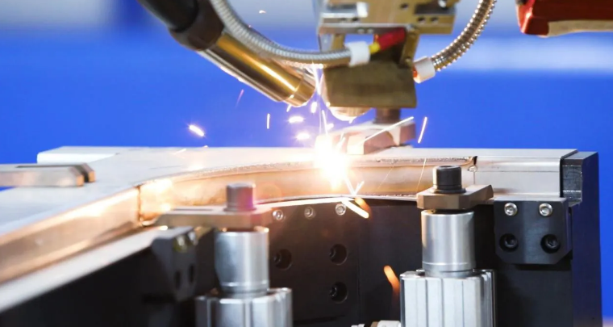
Gas laser welding plays a vital role in the automotive manufacturing industry. The choice of gas can have an impact on many aspects. These include laser beam interaction， shielding efficiency， bead performance and the equipment used to deliver the standard gas mixture and flow rate. And I would like to tell you that the choice of helium and argon will reduce the manufacturing costs for the vehicle.
Helium shielding gas brings the smallest average vapour particle size. This shows that for CO2 or YAG laser welding， pure helium is the best choice for controlling particle size. We must admit that helium does have a relatively high ionisation rate and a lower plasma formation voltage compared to argon， but it has a smaller molecular weight. Therefore， helium protective gas requires a larger flow rate to ensure that the metal vapour in the laser beam path is effectively expelled. As the unit cost of helium is higher than that of argon， this increases the average cost per foot of the welding process.
In order to optimise the shielding gas to achieve plasma suppression， vapour particle discharge and lower unit costs， we consider the use of an argon gas mixture of up to 40-50%. The higher the specific gravity， the lower the flow rate of the gas mixture required to expel the vapour particles. The gas mixture also provides an inert atmosphere for a longer period of time during the curing process of the weld pool， resulting in a higher welding speed. It also reduces the amount of trapped gas， thereby reducing the scrap rate due to porosity. Secondly， the reduced cure rate promotes grain growth and internal stress relief， which increases fatigue strength. Weld cracks due to the higher aspect ratio (weld depth/width) and subsequent stresses were all virtually removed due to the increased weld face width caused by the addition of GMAW filler metal.
The addition of small amounts of carbon dioxide and/or oxygen to the gas mixture， or their use as a secondary shielding gas for the GMAW process， can further improve the performance of the weld bead. The helium-argon gas mixture facilitates higher arc voltages and accordingly results in wider bead profiles and higher arc stability.
Therefore， 3-10% carbon dioxide can be added to stabilise the transmission and contraction of the arc. In some cases， 1-5% oxygen can be added to achieve medium to large arc stability and at the same time achieve a better connection (wetting) at the welding edge. Compared to carbon dioxide gas mixtures， oxygen easily provides a wide and shallow penetration distribution due to its lower ionisation rate and higher thermal conductivity properties.
Once the gas mixtures have been finalised for the required quality and productivity criteria， it is necessary to consider how they can be economically transported to the place of use. Users can take advantage of a low-cost supply of liquid argon by mixing these protective gases at the production site. Why not pay for argon， carbon dioxide or oxygen at the price of a premixed high-pressure helium cylinder?
Argon can be economically delivered in liquid argon cylinders to meet a monthly consumption of up to 35，000 cubic feet， an amount equivalent to a monthly gas mixture of 87，500 cubic feet. Larger monthly consumptions of argon can be optimised using bulk supply to achieve cost levels. The analysis also takes into account filling losses， monthly equipment costs， contractual restrictions on batch supply， and freight costs， among other factors.
On the other hand， helium is generally supplied via a high-pressure TubeTrailer or cylinder set. Mixing on site requires a mixing system which is able to accurately regulate the minute composition from 0-100%. The total quality system can be monitored by placing an analyser at the outlet of the mixer， which alarms as soon as the mixing ratio is outside the error range. Software and alarm systems are already in place to transmit this information to a desktop computer or to a more distant location by fax or email.
Properly designed hybrid laser gas delivery systems enable the user to achieve higher welding speeds and correspondingly higher productivity. Attention to shielding gas parameters such as type， flow rate， and impact angle will improve weld quality and reduce beam absorption and scattering effects.
The continuous development of auxiliary welding technology， combining methods such as GMAW and laser technology， allows the user to exploit the advantages of both technologies and benefit from them.
Translated with www.DeepL.com/Translator (free version)

