Differences in nitrogen generators for industrial use for different processes

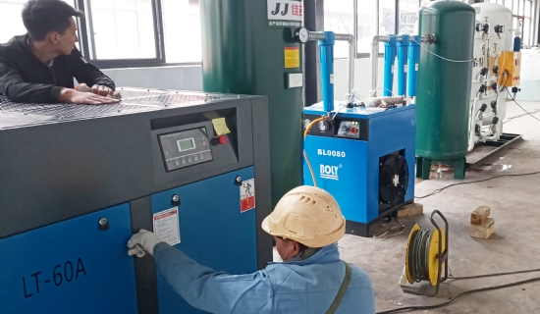
Nitrogen is essential for many industrial uses， mainly in the food and beverage industry. Since it is an inert gas， it prevents undesired oxidation of production materials. Therefore， these commercial companies need large amounts of nitrogen to extend the shelf life of their products. Only an on-site nitrogen generator can solve this problem for them. Many people want to know what a nitrogen generator is because it is not commonly available in the market.
Suzhou XITE produces different types of nitrogen generators that can meet the needs of all corporate customers.
PSA nitrogen generator
PSA nitrogen generator is one of the most popular ones using variable pressure adsorption technology. It has been in practice since the 1970s and the life of each generator is usually more than 10 years.
Membrane Nitrogen Generators
The membrane nitrogen generator is another popular product of the decade. It is primarily designed to produce low purity nitrogen up to 99.9% pure at very high pressures without the need to install a booster. Therefore， most companies handling petrochemicals， natural gas and petroleum products need this generator.
Liquid Nitrogen Generators
XITE produces liquid nitrogen generators. The latest technology is used to customize this generator to meet customer requirements. The nitrogen production capacity of these generators varies from 10 LPD to 2000 LPD.

