What is air separation equipment? What does it do?

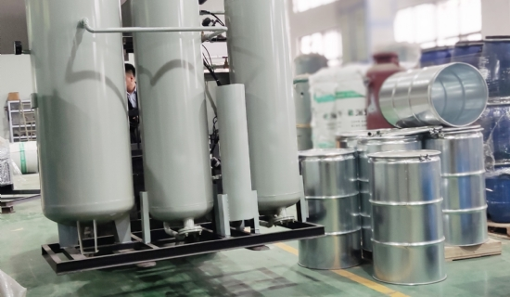
Air Separation - Simply put， it is a set of industrial equipment used to separate the various gas components of air， producing oxygen， nitrogen and argon. There are also rare gases helium， neon， argon， krypton， xenon， radon， etc.
A. Air separation can be divided into.
1， air filtration system; dust filtration， removal of dust and mechanical impurities
2， air compressor system; work on the gas， improve energy， with cooling capacity
3. Air pre-cooling system; pre-cooling of the gas to reduce energy consumption and improve economy. Pre-cooling primary throttling cycle is more economical than non-pre-cooling primary throttling cycle， increasing the refrigeration cycle， reducing the workload of heat exchangers and making full use of the product's refrigeration capacity
4， air purification system; explosion-proof， purification; air is a multi-component composition， in addition to oxygen， nitrogen and other gas components， there are water vapor， carbon dioxide， acetylene and a small amount of dust and other subsumed impurities. These impurities with the air into the air compressor and air separation equipment will bring greater harm， solid impurities will wear air compressor running parts， block the cooler， reduce the cooling effect; water vapor and carbon dioxide in the air cooling process will ice precipitation， will block the equipment and gas piping， resulting in air separation equipment can not be produced. Acetylene entering the air separation equipment can lead to explosive accidents， so in order to ensure the oxygen generator therefore， it is very necessary to remove these impurities in order to ensure the safe operation of the oxygen generator.
The use of solid adsorbent on the multi-component gas mixture of adsorption capacity differences; oxygen and nitrogen production ratio of another 1: (2.5 ~ 3.5); role: adsorption of water， carbon dioxide， acetylene， propylene， propane， heavy hydrocarbons， N2O and other impurities in the air.
5， air compression and expansion system; refrigeration system， heat exchange system， in the expansion process， there is an external power output， the expansion of the gas potential energy increases， the need to consume energy， this energy needs to be compensated with kinetic energy， so the gas temperature is bound to decrease. Heat exchange system: to achieve energy transfer， improve economy and achieve low-temperature operating conditions.
6， air separation system; nitrogen / oxygen separation is mainly composed of distillation tower system After air separation， the right amount of expanded air (20% to 25% of the air) can be sent directly to the upper tower for distillation; from the top of the lower tower or condensing evaporator top cover under the extraction of nitrogen， re-heated into the nitrogen turbine expander， by the expander and then returned by its cold， after the output as a product or emptying.
7、Oxygen compression; 8、Nitrogen compression; 9、Storage liquid vaporization system.
Brief description of the process
After removing dust and mechanical impurities in the inlet filter， the raw gas enters the air turbo compressor and is compressed to about 0.62MPa(A) for intercooling with the help of the intercooler， and then enters the air cooling tower for cooling.
By exchanging thermal mass with water in the direct contact air cooling tower， the air is cooled to ~10°C and then enters the alternating molecular sieve adsorber. The water used to cool the air has two parts: one part is room temperature water， pressurized by the pump into the middle of the air cooling tower; the other part is called chilled water， cooled by ordinary cooling water through the water nitrogen tower， and then pressurized by the deep cooling pump into the top of the air cooling tower.
The air coming from the air-cooling tower enters the molecular sieve adsorber， which is a vertical double adsorption tower layer used to remove water， carbon dioxide and some hydrocarbons from the air， thus getting clean and dry air. The two adsorbers are used alternately， i.e. one adsorber adsorbs impurities and the other adsorber is regenerated with dirty nitrogen gas.

