15m3/h， 99.99% purity nitrogen generator for heat treatment applications

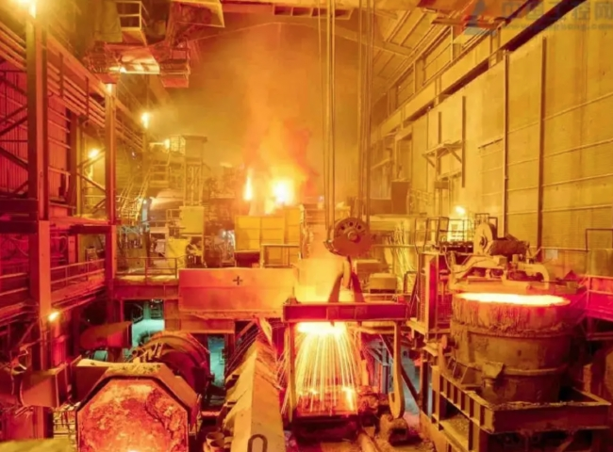
Seagate supplied a PSA nitrogen generator unit to an industrial facility.
The customer purchased the following specifications of nitrogen generator equipment from XITE.
Technology: Pressure Swing Adsorption (PSA)
Capacity: 15 m3/h
Purity: 99.99%.
XITE undertook the project to supply the complete nitrogen plant including air compressor and nitrogen storage tank on a turnkey basis.
Application.
The user of the nitrogen generator is one of the largest industrial companies in China， producing earth-moving equipment. The nitrogen will be used in nitriding furnaces and sealed quench furnaces (SQF) for case hardening of various components， as well as initial and emergency cleaning of the furnaces.
About PSA Nitrogen Generators
For those customers using nitrogen via cylinders， PSA nitrogen generators offer many benefits， including a significant reduction in the cost of nitrogen. PSA nitrogen generators are low maintenance， allowing customers 24 x 7 operation and peace of mind. PSA is a very mature technology and XITE is the largest manufacturer of PSA nitrogen generators in China， supplying over 1200 generators worldwide.

