Proportion of gas mixture required for welding of different materials

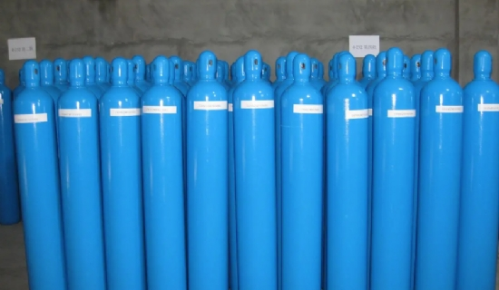
The ratio of the gas mixture can be configured according to the customer's needs.
The following are the general gas mixture ratios:
Ar is the main component gas
1、Ar+CO2 gas mixture: (CO2 volume percentage 16~28%) The most common is Ar:CO2=80/20
Applied in carbon steel and low alloy steel.
2、Ar+H2 mixed gas: (volume percentage of H2 is 1~8%)
Applied in nickel-based alloys.
3、Ar+O2 gas mixture: (The volume percentage of O2 is 1~5%)
Applied in carbon steel and low alloy steel
4、Ar+O2+CO2 gas mixture: (volume percentage of O2 is 3~8%， volume percentage of CO2 is 5~15%)
Carbon steel and low-alloy steel
5、Ar+CH4 gas mixture（volume percentage of CH4 is 9~12%）
N2 is the main component gas
6， N2 + H2 gas mixture (volume percentage of H2 is 5~20%)

