5 safety measures to ensure when working with nitrogen generators

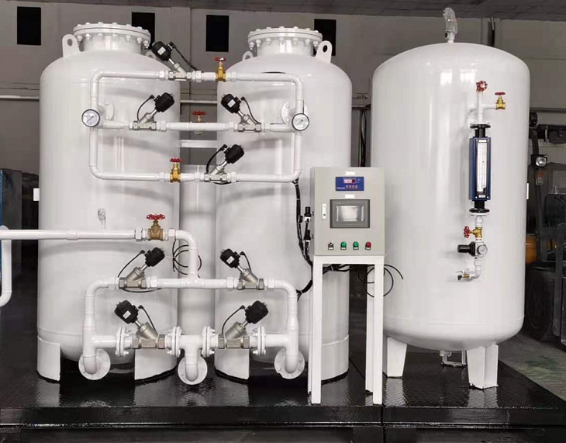
Nitrogen occupies most of the volume of the Earth's atmosphere - 78% - and is a colourless， odourless and tasteless gas. This inert gas has a very stable chemical structure - all nitrogen molecules form a triple bond with each other. The triple bond is the strongest bond in existence， making the molecule virtually unbreakable. Because of this stable structure， it does not react easily with other compounds， making it the toughest choice of all industries.
Which industries need an in-house nitrogen generator?
Nitrogen generators are used in numerous industry sectors， such as
Food processing
The packaging industry.
Manufacturing.
Steel processing and other meta-industries.
Paper industry.
Electronics industry， etc.
Nitrogen Generators Vs. Nitrogen Tanks - Which is better?
On-site nitrogen generators provide a steady supply of commercially sterile， 99.9% pure nitrogen from compressed air storage tanks. These nitrogen generator units are chosen over individual nitrogen tanks because the former not only provide a constant supply of nitrogen， but are also cost effective， allow full quality control of the gas and require less floor space.
Having said that， implanting nitrogen equipment has its own drawbacks.
Potential hazards of nitrogen generators
As nitrogen is a colourless and odourless gas， it is difficult to detect it in the event of a leak from the gas generator. One of the dangerous properties of nitrogen is that it can create an oxygen-deficient zone that can be hazardous to industry workers， and must therefore be handled with care anyway.
Nitrogen generators are generally divided into two types according to their function - PSA nitrogen generators (variable pressure absorption) and VPSA nitrogen generators (vacuum variable pressure absorption). You can read about the differences between them here.
Nitrogen generators usually use compressed air to produce nitrogen by removing the oxygen component from the atmosphere. This obviously has the potential to change the ambient oxygen level within your installation in the following ways
Nitrogen leaks may occur from buffers， vessels or duct work， which can reduce the ambient oxygen level.
Manual or automatic venting of "failed" nitrogen during purity control may also result in a reduction of the ambient oxygen level.
In the event of overpressure， the safety relief valve may discharge nitrogen， reducing the ambient oxygen level at the installation site.
During maintenance or inspection of nitrogen equipment， depressurisation may occur due to the discharge of the nitrogen container， which may also result in a reduction of the normal oxygen level in the air.
If you have installed a nitrogen generator unit in-house， or are planning to install one， in addition to finding the best nitrogen generator unit manufacturer in China， you should be aware of the following points to prevent all possible safety hazards
1. Portable Oxygen Monitors
According to the Steel Sector Safety Code established by the Chinese government ministry， individuals are only allowed to enter a vessel or any area adjacent to a pipe to work after ensuring that there is at least 19.5% oxygen in the air and after receiving written permission from a supervisor such as a department， division or equipment manager. In addition， every worker in the work area is required to carry a portable oxygen monitor at all times.
2. Air leakage
Routinely audit the condition of pressure vessels， pipework， equipment and connections at installation and during subsequent service periods. Ensure that the system is completely leak-proof.
3. Correct exhaust gas discharge
A common misconception is that the exhaust gas produced by the generator is 100% oxygen， but this is not the case， then only 35% to 45% of the oxygen is released and the rest is nitrogen. Vent the gas to an open area outside and use an exhaust pipe with a large diameter and as short a length as possible to prevent any back pressure. Place the appliance as close as possible to an external wall.
4. Safety valves
In some cases it is necessary to pipe a safety relief valve mounted on a pressure vessel to the outside. In such cases it is recommended to use a threaded outlet port to allow for simpler installation of the pipework. Again， the vessel should be placed as close to an external wall as possible.
5. 5. Use appropriate colour codes， labels and warning notices
All gas pipes should be clearly marked with a colour code in accordance with the relevant Chinese standards.
Warning signs informing workers of the presence of nitrogen and the possibility of oxygen depletion must be placed in susceptible areas such as plant rooms， equipment， containers and pipework.
Labels should be printed on all types of equipment， vessels and pipework in readable and understandable language to prevent possible contamination， asphyxiation， fire etc. as a result of workers' misconduct.
Translated with www.DeepL.com/Translator (free version)

