Nitrogen is widely used in cement plants that use pulverized coal
Inert gases such as nitrogen and carbon dioxide are important practical gases for coal-based cement plants as they help in fire protection and fire fighting applications. For use in clinker furnaces， coal is crushed into powder form， a process known as pulverization， and then used in the furnace.

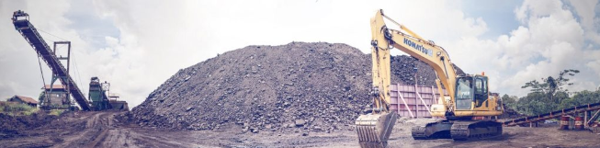
The use of pulverized coal has its own set of challenges when it comes to handling and storing coal. Coal has the ability to spontaneously combust if the environmental conditions are conducive to fire. In China， where ambient temperatures now exceed 40 degrees in the summer， pulverized coal easily catches fire and is a major problem in cement plants. The pulverized coal travels from the mill to the hopper and silo， and the fine pulverized coal is also collected in bag filters. During all these processes， inert gas is introduced in the cement plant to prevent fires.

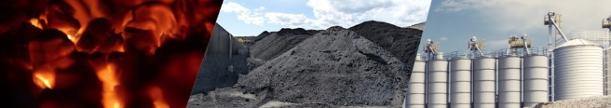
Traditionally， inert gas systems based on fuel combustion processes have been used. There are many benefits to using XITE PSA nitrogen for production applications， and more and more cement plants are using nitrogen instead of carbon dioxide.

