Nitrogen applications for the HVAC industry

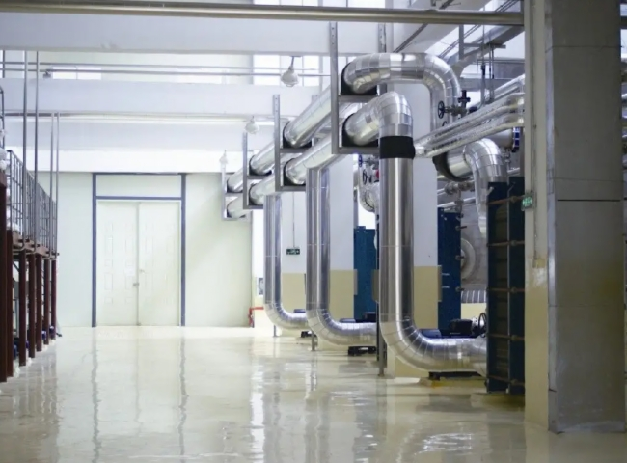
Nitrogen
HVAC includes heating， ventilation and air conditioning. HVAC are effective systems that exist around the air conditioning of each of us， whether they are in residential areas or in industrial locations. The focus of HVAC systems is to provide thermal control and comfort in a room using heat transfer， fluid dynamics and thermodynamics.
HVAC requires nitrogen throughout the testing， manufacturing and ongoing maintenance process. Nitrogen is used for pressure testing and cleaning of copper coils. Many times， manufacturers of HVAC systems pressurize the coils prior to shipment to verify that there are no leaks in them.
Nitrogen also eliminates oxidation of metals because it impedes the presence of moisture during the leak testing process.
In addition to these uses， nitrogen is used in gas-assisted laser cutting of sheet metal cabinets.
Since nitrogen makes up 78% of the atmosphere， the most advantageous option for all nitrogen users is to produce an interrupted supply of nitrogen for your industrial use at your own premises. Our systems are easy to install and use， and are manufactured with the latest technology. With our on-site gas generators， you can eliminate concerns about delivery or gas depletion.

