About intercoolers

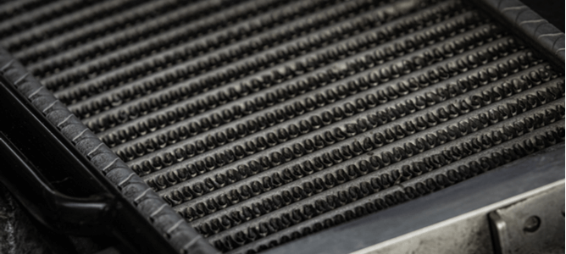
Some industrial manufacturing processes generate large amounts of heat which must be removed to maintain the integrity of the equipment and to prevent alterations to the finished product. As a result， the use of intercoolers and heat exchangers is quite common. Although it is easy to confuse the two， this article will highlight the obvious differences between these two types of process cooling equipment.
Heat exchangers or intercoolers?
People often confuse phrases such as "intercooler" and "heat exchanger" and do not understand the difference. We're here to set the record straight. Let's discuss the many aspects you need to know about intercoolers. Before deciding to use a heat exchanger or intercooler unit， industrial process managers must understand each type of equipment and how it works.
By definition， a heat exchanger is a generic term used to describe a device that pulls the heat generated by an industrial system out， resulting in rapid cooling. A heat exchanger usually consists of a pipe filled with coolant and uses the principle of thermodynamics (the flow of heat energy between two media in contact) to remove the heat from the process with which it is combined.
In simple terms， an intercooler is a cooling device whose function is to remove the heat generated by the air compression unit. Intercoolers are usually found in turbocharged engines and their function is to restore the air temperature in the air compressor to near ambient air values. The intercooler cools the air prior to the engine intake， earning the prefix intercooler.
Heat exchangers and intercoolers
From the many aspects we have mentioned so far， it is now easy to see the difference between an intercooler and a heat exchanger. The term heat exchanger can be used loosely to define a cooling device in which heat is exchanged between two media. At the same time， an intercooler is a special form of cooling equipment that achieves cooling within the air compressor unit.
In addition， heat exchangers are more flexible in terms of the range of cooling support they provide， as different variants exist， customised for most industrial cooling applications. Examples include
Shell and tube exchangers
Boilers and evaporators
Double tube heat exchangers
Plate heat exchangers
These heat exchanger types play a key role in a number of industrial processes including oil refining and cooling， fuel gas systems， petrochemical manufacturing and petroleum distillation.
How to choose an intercooler
Choosing the right intercooler for your unique operation does not have to be a daunting process. However， there are a number of key factors to consider before deciding on an intercooler to ensure the most compatible unit is selected.
Type of intercooler (air-cooled， water-cooled)
Expected system temperature
Size of the cooling operation
Maximum compressed air flow rate
Type of intercooler
Depending on the manufacturer's design and the operator's preference， the intercooler can be either air-cooled or water-cooled. While both configurations achieve adequate cooling of the compressed air， the availability of the cooling medium is a key selection criterion.
Air-cooled intercoolers can be used in almost any environment and use ambient air to draw heat away from the process in question. Water-cooled intercoolers require a steady flow of cold water for efficient heat exchange with the heated industrial process. Without a constant flow of water， a water-cooled intercooler would be an impractical option.
Expected system temperature
Every industrial application requires a unique temperature for the compressed air flowing through it. When deciding which type of intercooler to integrate， the operator must be aware of the temperature of the air entering the exchanger and the expected thermal reading at the outlet after cooling. Only intercoolers capable of achieving a satisfactory outlet pressure should be considered.
Sizing for cooling operations
Intercoolers of various sizes and thermal ratings are available for cooling turbocharged engines. Matching an appropriately sized intercooler to the cooling process is critical to operational efficiency and the life of the associated process components.
Maximum compressed air flow rate
The most efficient intercooler must achieve optimum cooling at the maximum air flow rate of the compressor to which it is connected. This is another key factor that all operators must consider when selecting intercooler equipment.
Low flow rate operations may benefit from a smaller size intercooler. In contrast， high flow rate processes are best served by equipment with a larger surface area， which allows for faster cooling to the required outlet temperature.
Intercooler alternatives
In operations where the integration of an intercooler is not practical， other heat exchanger units can be installed in continuity with the air compression unit. Aftercoolers are heat exchange devices that quickly cool the air just coming out of the compressor outlet.
This process cooling equipment is set up in a similar way to the intercooler， with tubes filled with water to extract heat from the compressed air (water-cooled type) or with compressed air tubes bathed in cold ambient air (air-cooled type). This type of unit can rapidly reduce the temperature of compressed air to between 5 and 20 degrees Fahrenheit.

