What are the properties and uses of oxygen

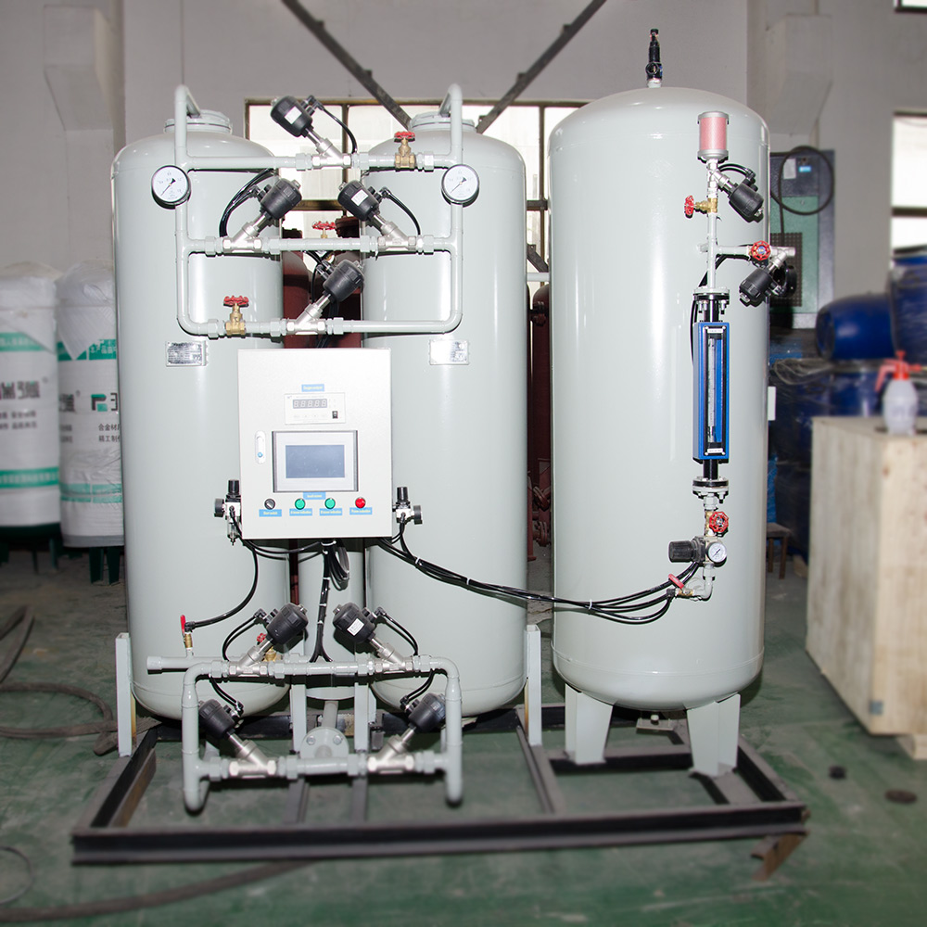
Properties of Oxygen:
Under normal conditions， it is a colourless， odourless gas that can be liquefied and solidified. It is not easily soluble in water. Slightly denser than air. Oxygen is a chemically active gas that reacts chemically with many substances， provides oxygen in the reaction， has oxidising properties and is a commonly used oxidising agent. Comparison of the phenomenon of combustion of substances in air and in oxygen.
Uses of oxygen:
1. smelting process.
In the steelmaking process blowing with high purity oxygen， oxygen and carbon and phosphorus， sulfur， silicon and other oxidation reaction， which not only reduces the carbon content of steel， but also conducive to the removal of phosphorus， sulfur， silicon and other impurities， and oxidation of the heat generated in the process is sufficient to maintain the temperature required for the steelmaking process， therefore， blowing oxygen not only shortens the smelting time， while improving the quality of steel. Blast furnace ironmaking， improve the oxygen concentration in the blast can reduce coke.
2. Chemical industry.
In the production of ammonia， oxygen is mainly used for the oxidation of raw gas， for example， the high temperature cracking of heavy oil， as well as the gasification of pulverised coal， etc.， in order to strengthen the process and improve the output of fertilizer.
3. Defence industry.
Liquid oxygen is a high quality flux for modern rockets， liquid oxygen is also needed as oxidising agent in supersonic aircraft， and combustible substances impregnated with liquid oxygen have strong explosive properties， and liquid oxygen explosives can be made.
4. Healthcare.
Supply respiration: used in hypoxia， low oxygen or no oxygen environment， for example: diving operation， mountaineering， high altitude flight， cosmic voyage， medical rescue， etc.， to improve the yield， in non-ferrous metal smelting， the use of oxygen-enriched can also shorten the smelting time to improve the yield.

