Nitrogen generator for CCV production line for high temperature cable manufacturing

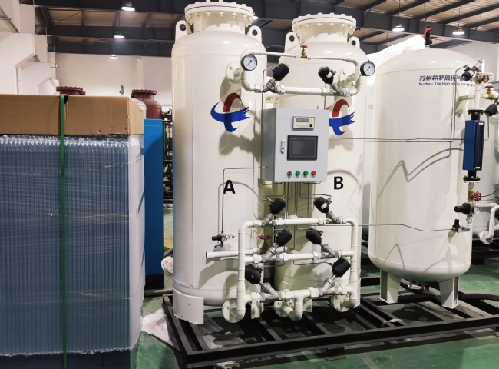
XITE supplied 2 sets of 100 m3/h nitrogen plants to a very well known manufacturer of high temperature cables.
The nitrogen was used in their CCV line for curing the cables in the conduit. The nitrogen at pressure and temperature allows for cross-linking of the cable and also for subsequent cooling.
These high purity nitrogen generators supplied by XITE Engineering Ltd. are equipped with high pressure nitrogen boosters and high pressure storage cylinders.
The customer has purchased the following sizes of nitrogen equipment from XITE
Technology: PSA nitrogen technology
Capacity: 100 m3/h each (2 pcs)
Application: CCV production line (H.T. cable manufacturing)
XITE has supplied more than 25 nitrogen plants for CCV to several companies in China， Asia and the Middle East. From an on-site nitrogen generator， nitrogen is produced at a pressure of 5 to 7 bar， then the nitrogen pressure is boosted to 25 bar by a booster compressor and stored in high pressure tanks as intermediate buffer storage.
The curing process requires a continuous supply of nitrogen at a pressure of 12 to 15 bar. XITE has successfully supplied high pressure nitrogen generators to meet these requirements.

