300m3/h membrane nitrogen generator for autoclave

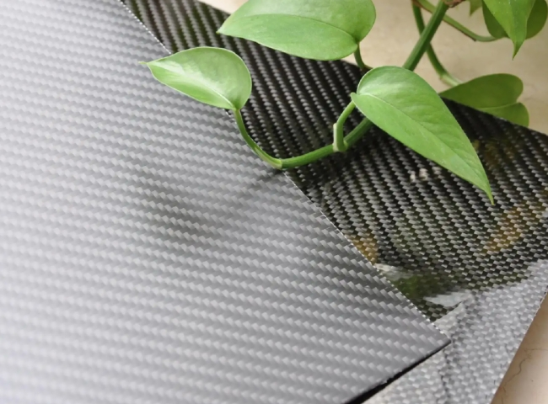
Did you know that many autoclaves maintain a nitrogen atmosphere during use?
XITE Company's customer is using 2 units of 300 m3/h nitrogen each to maintain a 24 x 7 nitrogen supply at their facility. The customer's main objective is to exclude oxygen and maintain an oxygen level below 5% in their autoclave while their high temperature， high pressure process is curing carbon fiber parts. Therefore， our 98% membrane nitrogen generator fully met the customer's requirements. (Oxygen levels below 2%).

