High purity oxygen for mechanical engineering applications

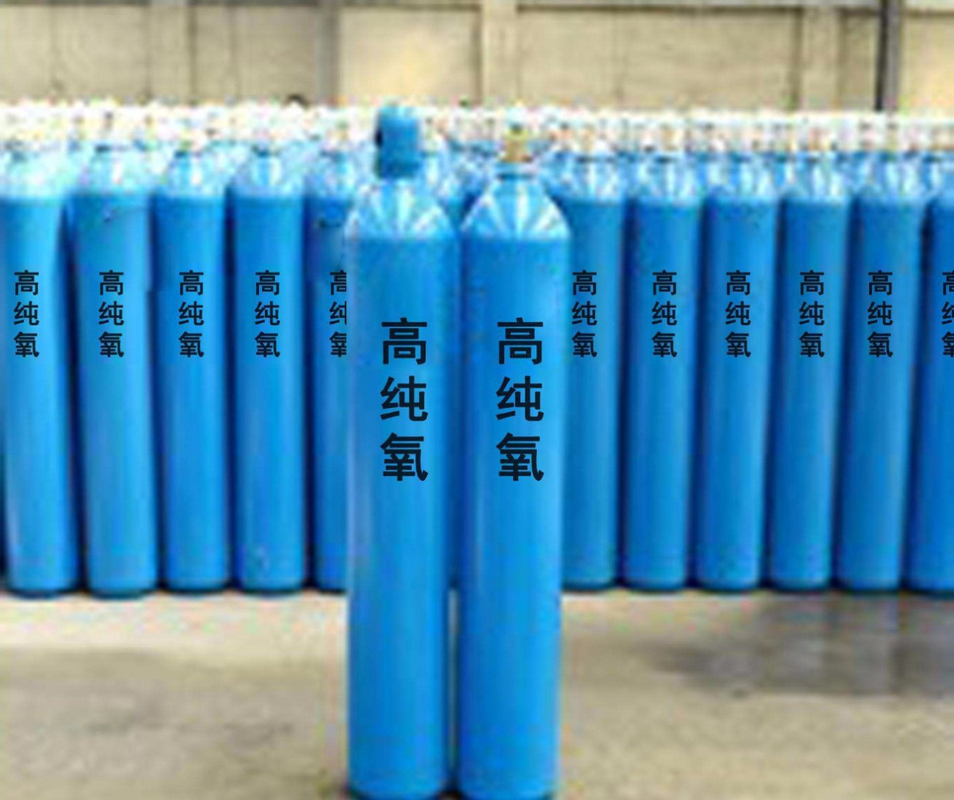
Oxygen， as one of the gases used by mankind for a very long time， is also the majority of the gases used today. High purity oxygen is mainly used in mechanical engineering:
Cutting， welding. Oxygen-oxygen flame， oxygen-acetylene flame is usually used to weld parts containers and cut sheet metal in mechanical processing. With oxygen fuelled propane flame can be quasi-stable cutting of complex parts， instead of casting， forging， milling， planing and sawing of some parts. The finish can reach D4-D6. In order to reduce costs and improve cutting efficiency and safety， it is also possible to use a mixture of methyl acetylene， propylene， propylene and propane called Peikin's stabilised gas mixed with oxygen for cutting， brazing and embedding. Underwater cutting and welding， mainly used to salvage shipwrecks， repair wharves， bridge piers， underwater pipelines and so on.
Underwater combustion cutting burner is divided into three kinds: ① oxygen， acetylene and compressed air (water depth up to 15m); ② oxygen， hydrogen and compressed air (water depth up to 40m); ③ the use of oxygen and liquid fuel (water depth up to 60m) Cutting 10mm steel plate per metre of oxygen consumption of 1.2m3. Oxygen Arc Welding can be welded silicon steel. Oxygen arc welding to oxygen and carbon dioxide binary gas mixture for shielding gas arc welding， the proportion of oxygen is higher than 20% +60%. Oxygen blowing in cutting process can improve machining accuracy. When cutting carbon steel with a high-speed steel cutter， oxygen injection at a pressure of 0.2-0.8 MPa has the same effect as cutting with a super-hard cutter. In casting pressure pouring light metal， in the pressure mould filled with oxygen， castings do not produce porosity， the quality will be improved. The reason for this is that the high purity oxygen reacts with the liquid metal to form hard oxide particles， which float within the metal， thus keeping the casting free of porosity. The strength of such castings can be increased by 30 per cent and the relative elongation can be increased by a factor of one.

