What you must know about PSA oxygen concentrators

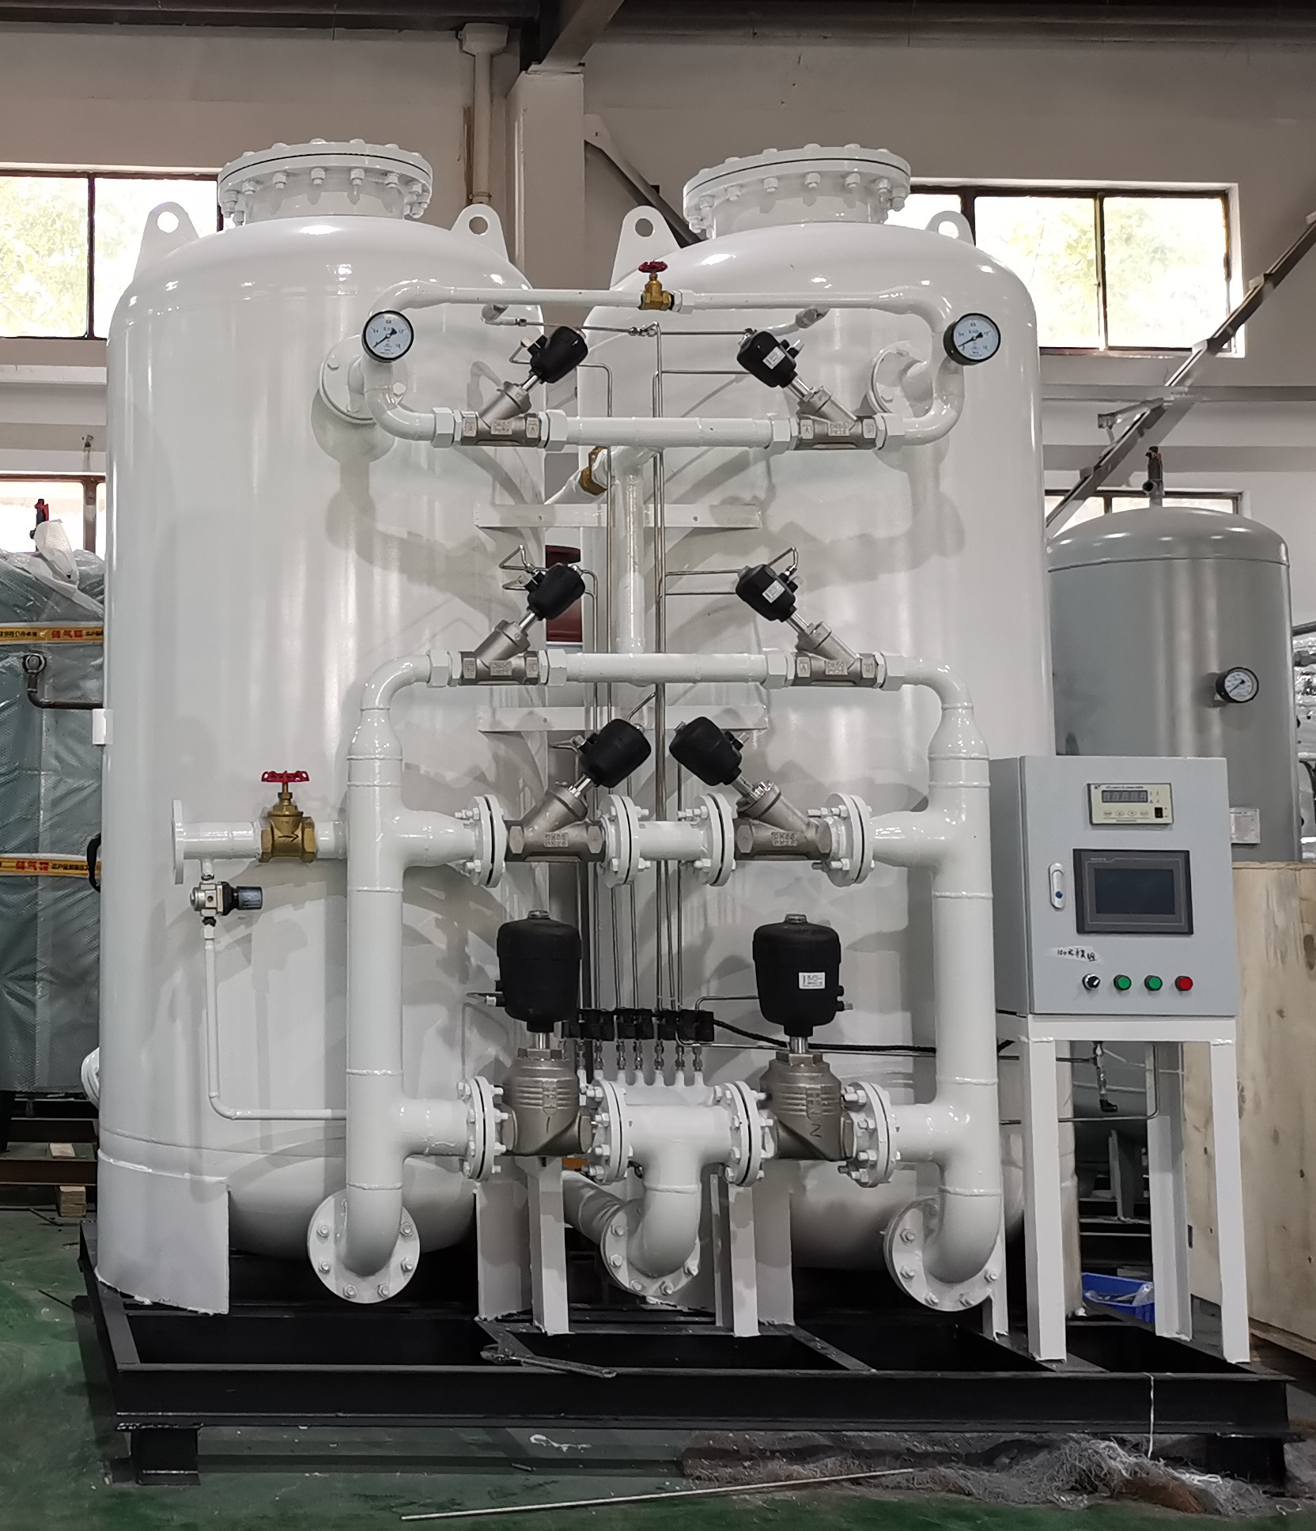
PSA oxygen generators use zeolite molecular sieves as adsorbents to produce oxygen using the PSA principle. At a certain pressure， the zeolite molecular sieve has a different oxygen/nitrogen adsorption capacity， i.e. the nitrogen adsorption capacity is much greater than the oxygen adsorption capacity.
What are the components of a PSA oxygen plant?
Air compressor and aftercooler
The air compressor compresses the air to 7.5 bar and cools it to ambient temperature in a shell and tube heat exchanger. The air compressor is unloaded with the help of a mechanical unloading.
Oxygen booster vessel
The oxygen from the PSA module will have a different purity depending on the pressure adsorbed during a one-minute cycle time. The excellent engineering of this vessel provides you with a high quality product. The output received is also obtained at a constant pressure and a constant average gas purity.
Air Receiver
This is a buffer vessel/small compressed air reservoir for a continuous supply of air to the system and therefore eliminates pressure pulsations.
In addition， moisture is drained from the bottom by means of an automatic drain.
Raw oxygen flow meter
A rotameter at the outlet of the oxygen booster vessel is used to check the flow of oxygen extracted from the PSA system.
Oxygen percentage analyser
A digital on-line oxygen analyser is installed to monitor the oxygen percentage level at the outlet.

