PSA nitrogen generator--Casual food packaging

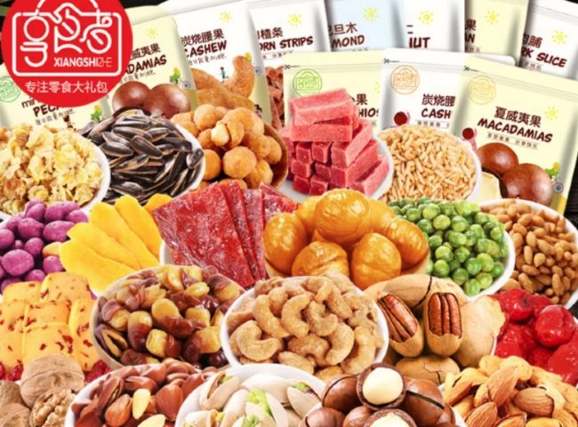
Gas generation， nitrogen， PSA nitrogen generator
Suzhou XITE has installed a 50 NM3/HR nitrogen generator for food packaging with 99.5% purity and 5 KG/CM2 working pressure.
Modified atmosphere packaging is a purification process in which the internal composition of the package is altered to improve its self-life. This is a normal practice in the food packaging industry， but it is also common in pharmaceutical packaging. This process reduces the amount of oxygen in order to slow down the growth of aerobic organisms while slowing down the oxidation process. The oxygen being replaced is very commonly replaced by nitrogen， although in some industries carbon dioxide is also used.
Nitrogen food packaging is used for preservation and storage because it is a non-reactive gas， non-toxic， odorless， and widely available. In fact， nitrogen makes up 78% of the air we breathe. All these properties make nitrogen food storage safe and affordable.
The range of products for food packaging sold by SUZHOU HIT is
Capacity nm3/hr: 50 NM3/HR

