Zeolite as a water treatment additive

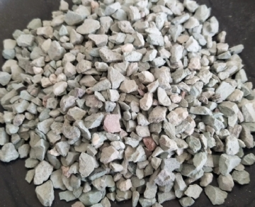
- Zeolites are eco-friendly adsorbents with a high affinity for nutrient compounds.
- Zeolites help to retain digestive material in the digestive tract， thus improving the absorption of nutrients.
- Reduces toxicity due to mycotoxins.
- Helps improve the granularity of feeds.

Aquaculture provides half of the human food for fish. This share is expected to rise to 62% by 203， as catches from wild capture fisheries are expected to level off (FAO 2014). On the other hand， the aquaculture industry is focusing on developing new methods to minimize toxic pollutants in aquaculture water in recirculation systems and wastewater from aquaculture ponds due to concerns about the harmful effects of aquaculture practices on the environment and more regulations on aquaculture wastewater. The use of eco-friendly adsorbents， such as natural zeolites， can yield one of the promising methods for treating wastewater toxins， feed toxins and improving growth. In addition to treating wastewater systems， zeolites play an important role as feed additives in animal feeds. This is due to the beneficial effects of zeolites on weight gain and growth performance， development of intestinal microflora， digestion of nutrients， enhancement of pancreatic enzyme activity and reduction in absorption of toxic products， slowing down the passage of diet through the intestine and more efficient utilization of nutrients. It has been found that zeolite has antimicrobial properties and the ability to adsorb mycotoxins and aflatoxins. Because of these properties， zeolites are used in a wide range of industrial and agricultural applications， especially in animal nutrition. What is zeolite?

Zeolites are crystalline， hydrated aluminosilicates of alkali and alkaline earth cations， consisting of a three-dimensional framework of Sio and AIO tetrahedra， connected by shared oxygen atoms. Natural and synthetic zeolites and porous materials are characterized by their ability to reversibly lose and gain water， adsorb molecules of appropriate diameter and exchange their constituent cations without significant changes to their structure. This property marks the widespread use of zeolites in industry and agriculture， especially in animal nutrition. Zeolites have been reported to contain high amounts of major and trace elements that are essential for the growth of aquatic animals， livestock and poultry. These trace elements are mainly used to help the body for many metabolic purposes and to aid in the utilization of other nutrients. In general， these elements are in an ionic state and can be released to these animals to improve their health.

