Technical characteristics of medical oxygen equipment

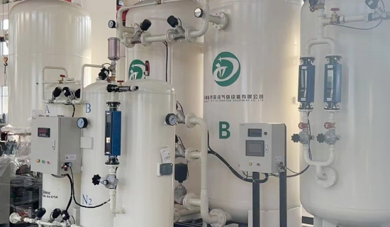
Oxygen generators are useful in providing a continuous supply of oxygen to save people's lives. As a result， many hospitals have abandoned the tradition of purchasing oxygen cylinders and have installed on-site oxygen generators. Suzhou XITE offers the most medium and large medical oxygen generators that can meet the needs of all hospitals. It is now available at reasonable prices， making the deal more profitable for hospital authorities.
Useful factors of XITE's medical oxygen generators
High purity levels
The oxygen produced by the on-site generator is typically 93 - 96%， which is the healthiest for inhalation. This purity is in line with the Chinese Pharmacopoeia recommendations for patient safety. If the purity drops below 90%， the oxygen generator will automatically shut down and switch to an alternate supply arrangement.
Extremely low dew point
Users do not need to worry about the moisture content of the oxygen generated， as the gas produced by XITE's oxygen generators is very dry. The dew point of oxygen can extend to -40 degrees Celsius， proving its dryness and giving it a level of purity.
Pressure of the oxygen supply
The pressure of the oxygen should be less than 5 bar to help the smooth transfer through the tubing to the receiver. However， if the pressure of the oxygen generator needs to be increased， a booster generator can be used.

