Application of on-site oxygen generator in glass blowing

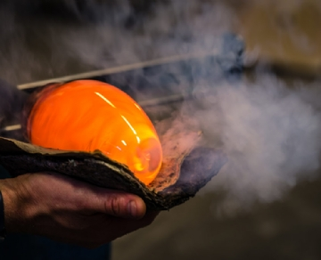
Glass blowing is a unique art that combines the skill of melting glass with the subtlety of blowing to form masterful decorative pieces. However， in order to work properly， the flame used by the glass blower must be a specific temperature. That's where oxygen comes in. With the high purity of oxygen provided by our 95% PSA on-site oxygen generator， glass blowers can ensure that their torches maintain the proper temperature to complete their masterpieces.
As mentioned earlier， glass blowers rely on oxygen as fuel for the burners and torches they use to melt glass. Basic compressed air does not produce the necessary heat. Oxygen is the only fuel source that ensures that the flame is hot enough to effectively and strategically melt quartz and borosilicate glass. In most cases， glass blowers will use oxygen in the 10-15 psi range， with 95% purity.
Why do glass blowers rely on oxygen generators (PSA oxygen machines， oxygen generators)?
Many artists do not need to manage and maintain oxygen cylinders and choose to use oxygen generators (PSA oxygen machines， oxygen generators) on site. There are many reasons for this.
It is reliable - not all glass blowers work in urban areas， and oxygen cylinder delivery is unreliable. With an on-site oxygen generator， there is no risk of running out of gas， so operations don't come to a halt.
It's affordable - oxygen cylinders can be expensive， and they're a recurring expense that won't go away. Instead， with on-site oxygen production， glass houses only have to worry about upfront costs. Once those costs are recovered， the artist can continue to produce oxygen at essentially no additional cost.
Is it safe - The art of glass blowing is dangerous enough， the last thing a glass blower needs to worry about is high-pressure cylinders exploding and damaging things in the shop.
Is it durable - Our on-site oxygen generators are built to handle the harshest environments， so no matter where the glass blowing takes place， the oxygen generators will stand the test of time.

