Nitrogen Applications for the HVAC Industry

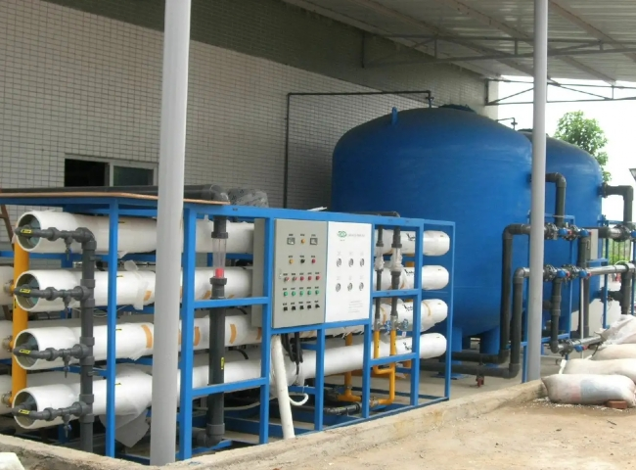
Whether it's an industrial or residential building， HVAC is all around us all.
What is HVAC?
HVAC includes heating， ventilation and air conditioning. HVAC is the effective system that exists around each of our air conditioners， whether they are in a residential area or in an industrial location. The focus of HVAC systems is to provide thermal control and comfort in the room using heat transfer， fluid dynamics and thermodynamics.
The Use of Nitrogen in HVAC Systems
HVAC requires nitrogen throughout the testing， manufacturing and ongoing maintenance process. Nitrogen is used for pressure testing and cleaning of copper coils. Many times， the manufacturer of the HVAC system pressurizes the coils before shipping to verify that there are no leaks in them.
Nitrogen also avoids oxidation of the metal because it hinders the presence of moisture during the leak testing process.
In addition to these uses， nitrogen is also used in gas-assisted laser cutting of sheet metal cabinets.
Since nitrogen makes up 78% of the atmosphere， the most advantageous option for all nitrogen users is to produce an intermittent supply of nitrogen for your industrial use at your own premises. Our systems are easy to install and use， and are manufactured with the latest technology. With our on-site gas generators， you can avoid the worry of delivery or running out of gas.
Buy a XITEc nitrogen generator today and save up to 90% of your gas usage costs.

