Nitrogen generator equipment for pesticide manufacturers

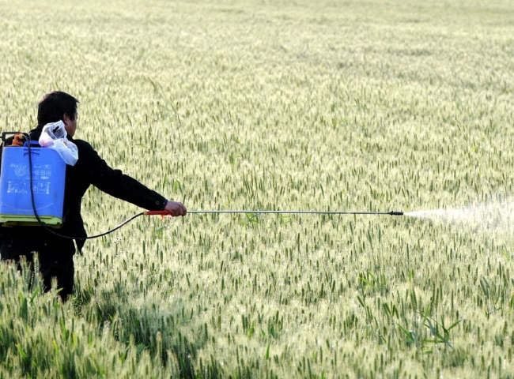
PSA Nitrogen Producer， Nitrogen Producer， Nitrogen Membrane
Suzhou XITE is a company that designs， manufactures and supplies PSA Nitrogen Producer. Nitrogen is used in different fields such as food packaging， where some organochlorine pesticides inhibit nitrogen fixing bacteria in the soil from supplementing natural nitrogen fertilizers， resulting in lower crop yields， stunted growth and an increasing need for additives to improve yields.
Air separation using membrane technology occurs when compressed air is forced into a vessel with a hollow tube in the middle surrounded by a polymeric hollow fiber. These hollow fibers selectively permeate oxygen， water vapor and other impurities through its side walls， allowing nitrogen to flow through its center and emerge as a product.
Simple design for reliable dry nitrogen production with purity up to 99.5%.
Cost-effective solution that eliminates reliance on high-pressure cylinders from natural gas companies
Includes standard per-filter package for clean， dry nitrogen output
Non-electrical option for installation in Class 1 Div 2 environments
Turnkey package with air compressor and storage tank available
Options include oxygen analyzers for real-time nitrogen purity monitoring and 3R cabinets for outdoor installations
The membrane technology in our nitrogen generators produces high purity nitrogen in the field using a safe， reliable and cost effective process. We have also designed nitrogen generators using PSA technology for many nitrogen generators. For More information about our nitrogen generation solutions， please contact Suzhou XITE.

