The role of the filter

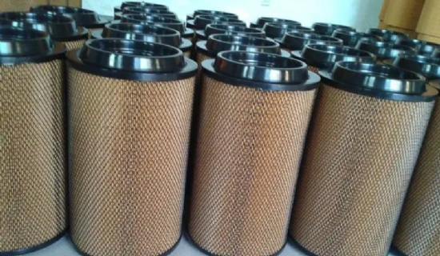
(1) suction filter: the filter is located in the suction line of the pump， filter out the residual contaminants in the oil tank through the air holes into the pollutants， there is a role in protecting the pump. However， in order to avoid the cavitation phenomenon of the pump， it is necessary to pay full attention to the pressure loss， and generally use 100-200 purpose of coarse metal mesh or notched wire material. Therefore， it is not a filter to control the pollution concentration of the system.
(2) High-pressure line filter (A): located on the outlet pipe of the pump， has the role of protecting the pollutants from entering the system. Therefore， it can control the contaminant concentration of the system. However， because it is a high-pressure main line， it is subject to the pulsation and pressure impact of the pump， so the material and strength of the filter element should be carefully considered.
(3) High-pressure line filter (B): In the system， this filter， also called terminal filter， is installed to protect the hydraulic parts that are particularly sensitive to pollution. Thus it tends to have a smaller filter size than other filters. Therefore， it is important to choose the one with large capacity when using it. In addition， the material and strength of the component should be considered as well as (A).
(4) Return filter: located in the return line of the system， its role is to capture the pollutants generated or invaded in the system before returning to the tank. Therefore it is the most effective and important filter to control the pollution concentration of the system. Although it is a low-pressure pipeline， but according to the operation of the transmission device， there will also be pulsation or pressure shock， so the component material and strength should be fully considered. Imported pump
(5) Circulation filter: located in the oil tank circulation of the return path， the capacity of the system is large， so in the requirement of strict cleanliness is often used， even if the system is not working， but also can be trapped in the tank pollutants to， therefore， reduce the pollution concentration of the best efficiency. In addition， a cooler is installed， and it has the advantages of simultaneous cooling and easy maintenance. But need to use special pump and motor， the cost is high.
(6) Air filter: located on the oil tank， with the prevention of pollutants due to changes in the volume of oil in the tank and mixed with the air into the tank. Therefore， the filtration accuracy should have the same performance as the filter， and the capacity should be left with sufficient margin to prevent the internal pressure of the tank from becoming negative due to hole blockage， causing the cavitation of the pump. Particular attention should be paid when the surrounding environment is harsh.

