Nitrogen plays a balancing role in micro-blast furnace ironmaking
Mini-blast furnace and ironmaking
Mini-blast furnaces (MBF) are often seen as miniature versions of conventional large blast furnaces (BF). These blast furnaces are ideally suited for small-scale operations. In fact， they are essentially the predecessors of the modern conventional final blast furnaces， so they have been in operation for a longer period of time. MBFs are located in many countries， but most MBFs are located in China， India， Brazil and Indonesia. The availability of plants and the perfection of this technology make MBFs the accepted route to ironmaking. In addition， most of the technologies designed， loaded and operated these days that have become the standard for today's modern large furnaces have also been adopted by MBFs.
The MBF is a vertical vertical shaft furnace with a crucible-type furnace chamber. A charge consisting of iron ore， coke or charcoal as reducing agent and fuel， and a melt， usually limestone or dolomite， is charged into the furnace top. The furnace works on the principle of a counter-flow reactor. As the charge descends through the shaft， it is preheated and pre-reduced by hot gases rising from the bottom of the furnace. These gases are generated by introducing hot air rich in oxygen through the blast port. The hot air burns the reducing agent and produces the reducing gases and the heat required for the reduction process that takes place in the furnace. The reduced charge material melts to form HM (liquid iron)， which is saturated with carbon and descends into the furnace chamber. The flux combines with impurities in the furnace charge to produce molten slag， which accumulates on top of the liquid iron in the furnace chamber. The liquid iron and liquid slag are periodically excavated from the furnace.
MBF shows flexibility and competitiveness， it is suitable for the production of basic and casting grade hot metal (HM). important features of MBF include simplicity and economy. other features of MBF are as follows.
Proven technology and equipment.
The design and equipment is simpler than conventional large BF.
It offers flexibility in ore roasting， which can range from 100% iron ore lumps to any mixture of iron ore lumps and agglomerates (sintered ore or pellets).
A range of reducing agents can be used， including low quality coke and charcoal.
The quality of the HM produced is similar to that of a conventional large BF.
It is similar in operation and maintenance to a conventional large incinerator， but is more flexible.
It has low capital costs and low equipment maintenance costs.
It is an economical and reliable source of HM for iron foundries and small steel mills， where it is used for forward integration with steelmaking plants consisting of induction furnaces/electric arc furnaces/energy optimization furnaces， and sometimes even with small basic oxygen furnaces.
As the name suggests， MBFs are small in size， with internal volumes ranging from 35 m3 to 600 m3. MBFs are typically low shaft furnaces， with effective furnace heights ranging from less than 12 m to around 20 m. MBFs are typically capable of productivity levels ranging from 2 tpd to well above 3 tpd.
Important features of MBFs
The MBF is a vertical shaft furnace with a vertical chimney superimposed on a crucible-like chamber. the MBF complex consists of the BF body， the hot blast furnace， the MBF top and charging system， several maintenance platforms， a storage system with several silos， a pouring platform and pouring chamber， a slag granulation system， a gas system， a BF gas purification system， a raw material and fuel supply system， a power supply and other utility The layout of the MBF is usually very compact and most of the facilities supporting HM production are installed very close to the furnace itself. Figure 1 shows a typical process flow diagram for an MBF with a dry gas cleaning unit.

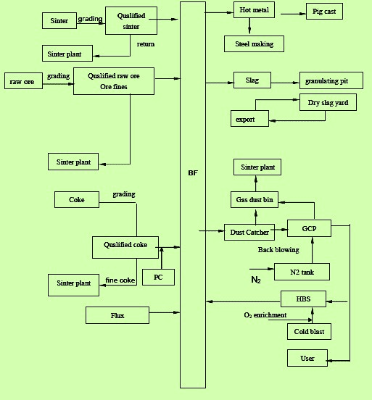
Fig. 1 Typical process flow diagram of an MBF with dry gas cleaning unit
The furnace is a process reactor and participates in the iron production system in the following way.
It receives already prepared burden material from the warehouse through the feed system.
It receives hot air generated by the blowers of the blast station and heated in the hot air furnace. The hot air is usually rich in oxygen.
It generates and transports HM and liquid slag.
It conveys raw BF gas to the gas cleaning system.
It receives cooling water and compressed air through a cooling and utility system.
It is supplied with electricity by the electrical system.
It is controlled by a command and control system.
The MBF usually has a freestanding frame structure with four columns supporting six platforms and skip bridges (in the case of skip charging) that stand directly on the RCC foundation. The furnace shell is usually built of structural steel plates of different thicknesses.
Typical shapes of two Chinese MBFs are shown in Table 1.

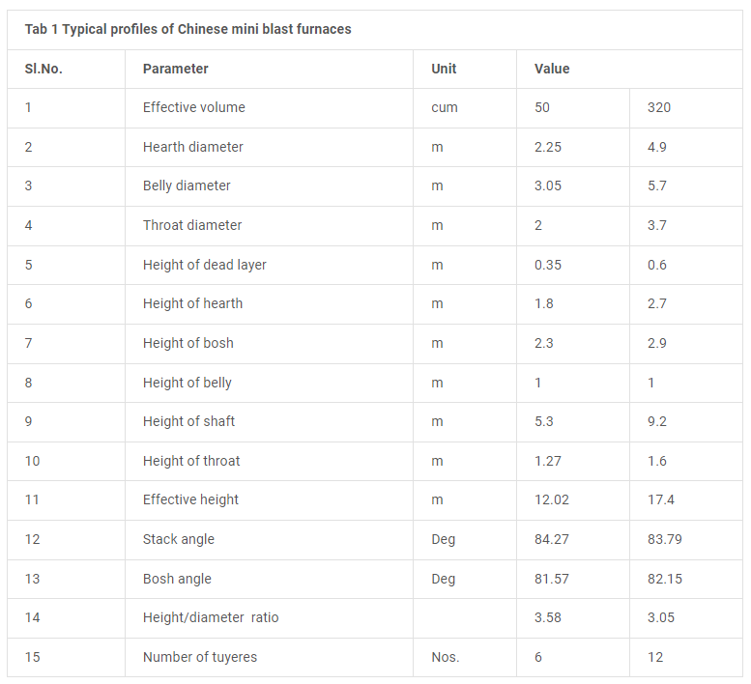
In modern MBF， semi-graphite carbon blocks are usually used in the bottom of the BF， while cast carbon blocks are used in the furnace chamber. The carbon block has good thermal conductivity and erosion resistance， which can effectively protect the furnace bottom and chamber. The inner wall of the furnace chamber is usually made of ceramic cup structure and lined with alumina. Corundum bricks and alumina bricks are used in the taphole area and slag mouth area respectively. The furnace chamber， furnace belly and part of the chimney area are usually lined with alumina bricks. High density clay bricks are used for the lining of the upper chimney area. The inner shell of the furnace is usually sprayed with alumina casting compound with a thickness of 70 mm. For the BF throat and top lining， welded anchor bolts and a layer of heat and wear resistant castables are used. Depending on the design of the furnace lining， the expected operating life of the MBF varies in the range of 5 to more than 10 years.
Increasing the hot air temperature is one of the main measures to increase the amount of pulverized coal injected into the MBF and to reduce the coke rate in the MBF. Hot air systems are usually designed in such a way that the hot air temperature is maintained at 1200 degrees Celsius by using BF gas as fuel. Today， the MBF is equipped with three hot air furnaces with a rotating tangential dome combustion design.
The hot air furnaces are fed with hot air from the main blower duct through the blower duct. The spout is installed together with the spout cooler. Both are made of copper. The number of concentrators installed in the MBF depends on the useful volume of the MBF and is designed for optimum blast velocity， which is usually between 210 m/s and 230 m/s under operating conditions.
Today， modern MBFs have a tap through which hot metal and molten slag flow. They are separated by a skimmer plate that is properly positioned in the HM runner on the working platform. In some MBFs， there are separate slag tanks for tapping liquid slag. The hot metal flows to the ladle or torpedo car， while the liquid slag is conveyed to the slag granulation system.
For the cooling plates used in the MBF， a three-section plain panel is used for the bottom and furnace chamber， and bosch and belly plates with inserted refractory material are used. To effectively support the brick lining of the lower stack and to reduce the openings in the BF shell to improve the sealing of the MBF， stepped furnace bars are being used in the stack area. Stepped ladders of ferritic ductile iron are generally used for the middle and lower stacks. Seamless steel tubes are cast in steel beams with ribs on the hot surface of the beams. The carbon material is compacted in the recesses. Water cooling is usually used at the bottom of the MBF. The cupola system is cooled by a special water cooling system.
Other auxiliary equipment in the blast furnace are (i) 2-stage throat armor， (ii) "throat infrared image cameras" installed near the throat charge line to detect the distribution of the charge in the throat area， and (iii) top water jets and cooling devices， which are used when the top temperature is very high.
Usually， MBFs are equipped with skip loading systems. In some MBFs， a conveyor belt loading is used instead of skip loading. For top loading of MBFs， two systems are in use， namely (i) double bellows loading with dispensers， and (ii) bellows-free top system. Modern MBFs use the bell-less top system.
In the case of bell-less top， two types of dispensing， namely (i) ring type (single ring type， multi-ring type) and (ii) fixed point type， are usually used. In the case of ring type dispensing， the material in the hopper is loaded into the furnace through the dispensing slots of concentric rings (single ring) or multiple concentric rings (multiple rings). In the case of single-ring dispensing， the dispensing slots are kept at the same specified tilt angle during charging. In case of multi-ring dispensing， the tilt angle can be changed several times during charging. One or more turns of dispensing can be performed at each angular position. In the case of fixed dispensing， the dispensing slot is positioned at the specified tilt angle to dispense the material to the specified location. Fan dispensing can also be accomplished with a bell-less top loading device. Usually， nitrogen is used for equalization purposes.
The charging height (charge line) in the furnace is controlled by two charge rods. During normal production， continuous charge level detection is automatically performed by means of the charge rods， which are lowered as the charge level drops. When the specified charge level is reached， the bars are lifted. The charge level is displayed in the control room.
The pouring house is usually rectangular in shape with a steel roof， a slope of 1:12 and RCC columns. ventilation windows are usually provided in the roof design. The casting house is equipped with a hydraulically operated mud gun and a hydraulically/pneumatically operated drilling rig with holes. The casting room is usually fully de-dusted by a bag filter system.
The BF gas produced in the MBF is taken out by 4 number of separators， then 4 number of risers， then 2 number of risers are gathered to 1 number of fallers and finally to the dust collector. The normal temperature of the furnace top gas is between 100 degrees Celsius and 300 degrees Celsius， with a maximum temperature of 400 degrees Celsius. Both suction ports of the furnace top are equipped with 1 exhaust valve， which is normally driven by a hydraulic cylinder. The dust collector works according to the gravity principle and removes coarse dust from the alkaline gas. The BF gas from the dust collector is further purified in a wet gas cleaning system consisting of a saturator and primary and secondary scrubbers， or in a dry gas cleaning system consisting of a low-pressure dust bag filter using nitrogen back-blowing of the dust.
The operation of the MBF is similar to that of conventional large BFs. As the charge loaded into the top of the blast furnace， i.e. the iron charge (sinter/pellet ore and lump ore)， the reducing agent (charcoal or BF coke) and the melt (limestone and dolomite) descend through the chimney， they are preheated by the hot air rising from the furnace chamber and by the hot air introduced through the vent at the bottom of the shaft located above the furnace chamber.
The heated air burns most of the BF coke loaded from the top to produce the heat required for the process and to provide reducing gases to remove oxygen from the ore. The reduced iron is melted and flows to the bottom of the furnace chamber. The flux combines with impurities in the ore to produce slag， which also melts and accumulates on top of the iron liquid in the furnace chamber. From time to time， liquid iron and liquid slag are drained out of the furnace through the tapping holes.
These days， MBFs are equipped with pulverized coal injection (PCI)， which is carried out at the air outlet. Modern MBFs can have a PCI rate of 150 kg/t HM. common operating parameters of MBFs are given in Table 2.

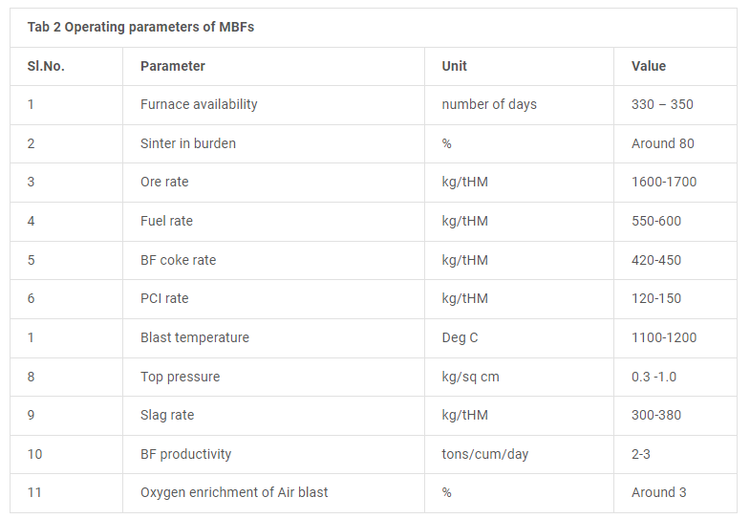

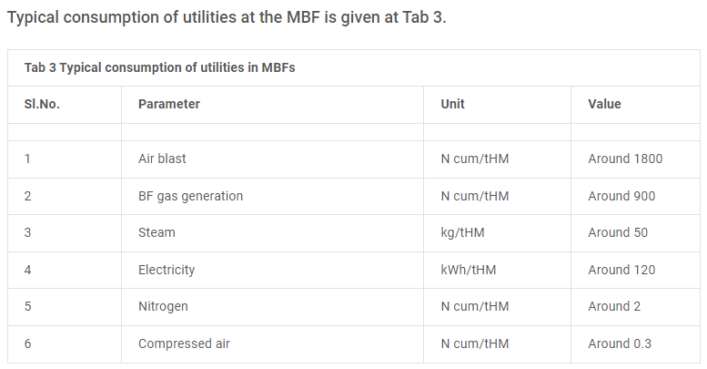
Control and supervision of the entire MBF operation is usually carried out from the MBF control room， which is usually located near the MBF working platform. The control system usually consists of a supervisory station， main PLC， alarms， interlocks and protection devices. A remote station is also typically installed in the raw material handling control room. The system is connected via a network. The monitoring system is usually used to control process parameters， trend logging and alarm logging. A number of field instruments are installed to measure and control all process parameters. Some important measurements include (i) pressure measurement， (ii) temperature measurement， (iii) flow measurement， (iv) BF gas dust level measurement， (v) stock level， chute angle and throttle opening measurement， and (vi) weight measurement of loaded material， etc. The control cabin for the operation of the foundry equipment is located in a secure location in the foundry itself， from where the operator can see the equipment.
MBF's water cooling system typically requires continuous industrial water for (i) blast furnace shell cooling， (ii) air outlet and air outlet cooler cooling， (iii) wet gas cleaning systems， (iv) slag pelletizing， (v) BF top hydraulic system cooling， and (vi) mud gun/drill hydraulic system cooling. All water is recirculated. An elevated water tank is usually provided for emergency needs in case of power failure. The main parameters related to all water systems are monitored through a supervisory system in the control room.

