Oxygenation in aquaculture

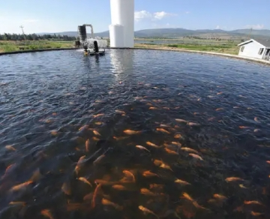

To meet the growing global demand for seafood， more and more fish need to be raised in fish farms. Aquaculture is an important link in the agricultural chain， protecting the oceans from overfishing and producing healthy food with very high feed conversion efficiency.

Dissolved oxygen is the most important factor for good results in fish farming， as fish absorb oxygen through direct contact with water.

The current trend in intensive aquaculture systems is to aim for high population density and low water consumption per kilogram of biomass. Without oxygen this goal cannot be achieved. By enriching water with oxygen， fish and seafood farmers can protect their fish populations from oxygen suffocation during peak consumption and growth periods.

Adequate levels of oxygen in the water at all times not only ensure growth， but also promote fish health， appetite and general well-being. Oxygen also helps to reduce the effects of temperature-induced stress in fish.

Application expertise

When used properly， oxygenation can reduce risk factors and increase profits， but when used incorrectly it can be counterproductive. Ultimately， oxygen is not a substitute for water - too much of it can be harmful. Proper oxygenation techniques can smoothly increase stocking densities， thus ensuring optimal feed conversion and the highest survival rates under optimal breeding conditions.

This is where we can help. We supply both oxygen and oxygen generator equipment， which are carefully and continuously optimized in close cooperation with our customers.

