How to use nitrogen generator for pet food packaging
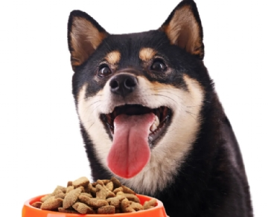
A key factor in the success of any dog food is its good shelf life. Dog owners don't want to throw away extra food because their dogs can't eat it until it expires. Therefore， when dog food companies such as NAPP manufacturing want to extend the shelf life of dog food， they will turn to nitrogen.
Why dog food companies need nitrogen
As mentioned earlier， nitrogen in dog food packaging helps to extend the shelf life of food. It does this by removing oxygen and filling the space with nitrogen. When there is no oxygen in the package， bacteria cannot survive. When you don't have to worry about mold or mold growth， your product will last longer on the shelf. In addition， the nitrogen in the dog food packaging helps to maintain its quality， so when your consumer feeds it to their dog， it is the same as the product you put in the bag.

Cylinder problems
Many dog food manufacturers will use cylinders to receive their nitrogen， which is what NAPP manufacturing has been doing. When nitrogen is received only through cylinders， the company has to rely on delivery， and if they run out， production will stop until more can be delivered. Not only that， the nitrogen cylinders may also be inconsistent. Most nitrogen cylinders do not have purity indicators or volume measurements.
NAPP manufacturing has personally experienced this kind of trouble. Some of their production cycles have acceptable shelf life， while others fail inspection. Moreover， since the cylinder has no control device， they cannot know whether the problem is insufficient nitrogen and / or inconsistent purity.

